A PROJECT REPORT

ON

**“Sign Language Conversion”**

PROJECT SUBMITTED TO

**P.G. DEPARTMENT OF COMPUTER APPLICATIONS (MCA)**

**MODEL INSTITUTITE OF ENGINEERING AND TECHNOLOGY (AUTONOMOUS), JAMMU**

In partial fulfilment of the requirement for the

Award of Degree of

**MASTER OF COMPUTER APPLICATIONS**

**Submitted by:**

Aniket Sharma(2022D1R013)

Divyansh Gupta(2022D1R015)

**Under the Guidance of**

Mr. Vishal Gupta

(Head)

P.G Department of Computer Applications

MIET, Jammu

**(SESSION:2022-2024)**

**MODEL INSTITUTE OF ENGINEERING AND TECHNOLOGY**

**(AUTONOMOUS)**

**NAAC Accredited: A Grade and Permanently Affiliated to University of Jammu.**

**KOT BHALWAL, JAMMU-181122**

A PROJECT REPORT

ON

**“Sign Language Conversion”**

PROJECT SUBMITTED TO

**P.G. DEPARTMENT OF COMPUTER APPLICATIONS (MCA)**

**MODEL INSTITUTITE OF ENGINEERING AND TECHNOLOGY (AUTONOMOUS), JAMMU**

In partial fulfilment of the requirement for the

Award of Degree of

**MASTER OF COMPUTER APPLICATIONS**

**Submitted by:**

Aniket Sharma(2022D1R013)

**Under the Guidance of**

Mr. Vishal Gupta

(Associate Professor & Head)

**(SESSION:2022-2024)**

**MODEL INSTITUTE OF ENGINEERING AND TECHNOLOGY**

**(AUTONOMOUS)**

**NAAC Accredited: A Grade and Permanently Affiliated to University of Jammu.**

**KOT BHALWAL, JAMMU-181122**



**CERTIFICATE**

This is to certify that the project entitled “**Sign Language Conversion**” submitted by **Mr. Aniket Sharma** bearing university Roll No. **2022D1R013** in partial fulfilment of the requirements for the award of the degree of **Master of Computer Applications (MCA)** course session **2022-2024. P.G. Department of Computer Applications of Model Institute of Engineering and Technology (MIET)** is a record of the student’s own work carried out under my supervision and guidance, to the best of our knowledge, this project has not been presented as a part of any other academic work to any other university or institution for the award of any degree or diploma.

**Project Supervisor:**

**Mr. Vishal Gupta**

**Mr. Vishal Gupta**

**(Associate Professor & Head MCA)**

**MIET, Jammu.**



**CERTIFICATE**

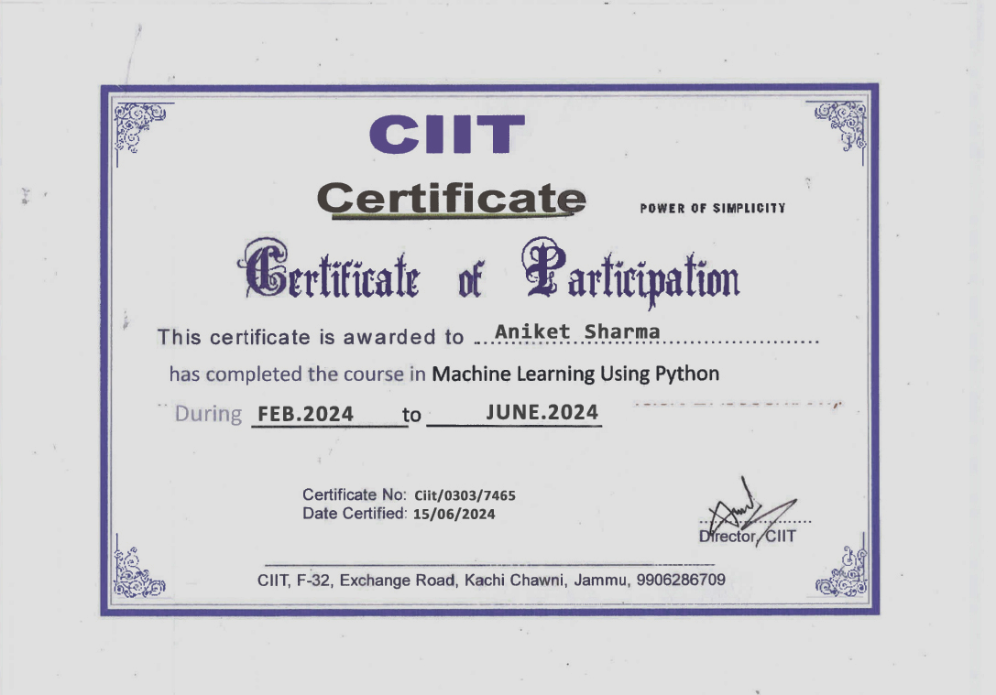

**ACKNOWLEDGEMENT**

The success of any project is never limited to the individual undertaking the project but depends largely on the encouragement and guidelines of many others. I take this opportunity to express my gratitude to the people who have been instrumental in the successful completion of the project.

I respect and thank Professor GS Sambyal for his guidance and constant encouragement through the MCA course. I am extremely grateful to him for providing such a nice support and guidance though he had busy schedule.

I would like to convey my gratitude and deep regard to the head of the MCA Department, Mr. Vishal Gupta for taking all the pains and interest in our development in all spheres and for his invaluable assistance and inspiration.

I would like to show my greatest appreciation to project mentor Mr. Vishal Gupta for being a motivating and guiding force all along the way. Without her support, meticulous effort, encouragement and supervision this project would not have materialized.

I wish to extend my thanks to Mr. Sourav Verma of CIIT for his support, insightful comments and his invaluable constructive suggestions to improve the quality of this project and for providing a new direction to my efforts.

Finally, I am grateful to the Almighty, my parents, my family members and all the people for their moral support in completion of my project.

Aniket Sharma

**DECLARATION**

I, Aniket Sharma hereby declare that the project work entitled “Sign Language Conversion” submitted to MODEL INSTITUTE OF ENGINEERING AND TECHNOLOGY(MIET), Jammu is a record of an original work done by us and under the guidance of Mr. Vishal Gupta, Associate Professor, MIET and this project work is submitted in partial fulfilment of the requirements of the award of the degree of Master of Computer Applications (MCA) Course Session 2022-2024, P.G. Department of Computer Applications and has not presented as a part of any other academic work to any other university or institution for the award of any degree or diploma.

Aniket Sharma

(2022D1R013)

**PREFACE**

This project report contains the summary of all the knowledge and resources that we acquired while working on it.

We have learned a lot about making Deep Learning applications.

It consists of modular description of project; individual description of the modules designed and developed with their detailed description, need to develop the application, various hardware and software requirements.

Various technologies that we used are Mediapipe with OpenCV and Python etc.

**ABSTRACT**

The inability to speak is considered a true disability. People with this disability use different modes to communicate with others. There are several methods available for their communication, one of which is sign language. Developing a sign language application for deaf people can be very important, as it enables them to communicate easily with those who do not understand sign language. Our project aims to take the basic step in bridging the communication gap between hearing individuals and those who are deaf or mute, using sign language.

The main focus of this work is to create a vision-based system to identify sign language gestures from video sequences. The reason for choosing a vision-based system is that it provides a simpler and more intuitive way of communication. In this report, 37 different gestures have been considered.

This project involves an implementation using a Random Forest classifier with a Mediapipe hand-tracking framework for Sign Language Conversion. After presenting the details of the training procedure setup, we proceed to evaluate the system on standard benchmark sets. We report an average accuracy of 99%, which demonstrates that the proposed model is efficient, precise, and robust.

Real-time, accurate detection using the Random Forest classifier algorithm without any wearable sensors makes this technology more comfortable and easier to use. All our core demos and peak train architecture have been released under an open-source license in our public repository.

**TABLE OF CONTENTS**

CHAPTER-1 INTRODUCTION 1-5

1.1 Introduction………………………………………………...1

1.2 Objectives Of The Project………………………………….2

1.3 Features Of The Project………………………………..…...3

1.4 Project Category……………………………………...…….3

1.5 SQT (Software Quality Testing) ...........................................4

1.5.1 Characteristics Of SQT...............................................5

CHAPTER-2 LANGUAGES AND PLATFORM INTRODUCTION 6-10

2.1 Languages Used......................................................................6

2.1.1 About Python..................................................................6

2.1.2 What is Machine Learning..............................................7

2.1.3 Python using Machine Learning.....................................8

2.2. Platform Introduction.............................................................9

2.2.1 What is PyCharm............................................................9

2.2.2 PyCharm Tools……………..........................................10

CHAPTER-3 SPECIFICATION OF PROJECT 11-24

3.1 Purpose Of Project ................................................................11

3.1.1 Scope.............................................................................11

3.1.2 General Description……………………......................12

3.1.3 Project Function……………………………….….......13

CHAPTER-4 INTRODUCTION TO TECHNOLOGIES 14-20

4.1 Introduction To Technology ..................................................14

4.2 Technology Used…………………………………………...14

4.2.1 Computer Vision............................................................15

4.2.2 Image Processing……………………...........................16

4.2.3 Object Detection……………………………………....17

4.2.4 Text To Speech...............................................................18

4.2.5 Machine Learning……………………..........................19

4.2.6 Pattern Recognition……………………………………20

CHAPTER-5 INTRODUCTION TO LIBRARIES 21-28

5.1 Introduction To Libraries........................................................21

5.2 Libraries Used…………………………….……………........22

5.2.1 Numpy............................................................................23

5.2.2 Media pipe...…..…….……............................................24

5.2.3 Sklearn…...…...…….………….….…………………...25

5.2.4 OpenCv...........................................................................26

5.2.5 Tkinter….……...………….….….….............................27

5.2.6 Pyttsx3……………………….…....…………………...28

CHAPTER-6 REQUIREMENTS 29-30

6.1 Requirements..........................................................................29

6.1.1 Hardware Requirements……………………………....29

6.1.2 Software Requirements…………………….................30

CHAPTER-7 SOFTWARE DEVELOPMENT LIFE CYCLE 31-32

7.1 SDLC Model..........................................................................31

7.1.1 Phases Of SDLC Model……………………………....32

CHAPTER-8 SYSTEM ANALYSIS AND DESIGN 33-37

8.1 Requirement Analysis.............................................................33

8.1.1 Problem Recongnition...................................................33

8.1.2 Evaluation and Synthesis...............................................34

8.1.3 Feasibility Study............................................................34

8.2. System Design.......................................................................35

8.2.1 Design Objectives…….................................................35

8.2.2 Working Methodology………….…………………….36

8.2.3 Architectural Design………………………………….37

CHAPTER-9 RESEARCH METHODOLOGY 38-43

9.1 Flowchart.............................................................................38

9.2 Workflow Diagram………...……...…….…………….......39

9.3 Application Working Diagram.............................................41

CHAPTER-10 IMPLEMENTATION 44-46

10.1 Implementation....................................................................44

10.1.1 Steps For Implementing SLR System……………...44

CHAPTER-11 CODING 47-57

11.1 Code For Hand Landmarking.............................................47

11.2 Main File.............................................................................50

CHAPTER-12 TESTING & RESULT 58-61

12.1 Testing.................................................................................55

12.2 Result For SLR System …………......................................60

CHAPTER-13 CONCLUSION AND FUTURE SCOPE 62-64

13.1 Conclusion..........................................................................62

13.2 Future Scope…………………...........................................63

CHAPTER-14 BIBLIOGRAPHY 65-70

14.1 Dataset……………............................................................64

14.2 Sites And References..........................................................69

CHAPTER-1 INTRODUCTION

1.1 Introduction

1.2 Objectives Of The Project

1.3 Features Of The Project

1.4 Project Category

1.5 SQT (Software Quality Testing)

1.5.1 Characteristics Of SQT

* 1. Introduction

Sign Language significantly facilitates communication in the deaf community. Sign language is a language in which communication is based on visual sign patterns to express one’s feelings. There is a communication gap when a deaf community wants to express their views, thought of speech and hearing with normal people.

Currently, two communities mostly rely on human-based translator which can be expensive and inconvenient. With the development in areas of deep learning and computer vision, researchers have developed various automatic sign language recognition methods that can interpret sign gestures in an understandable way. These narrow downs the communication gap between impaired and normal people. This also empowers deaf-mute people to stand with an equal opportunity and improve personal growth.

In accordance with the report of the World Federation of the Deaf (WFD) over 5% of the world’s population (≈ 360 million people) has hearing impairment including 328 million adults and 32 Million children. Approximately there are about 300 sign language is in use around the globe. Sign language recognition is a challenging task as sign language alphabets are different for different sign languages. For instance, American Sign Language (ASL) alphabets vary widely from Indian Sign Language or Italian Sign Language. Thus, Sign language varies from region to region. Moreover, articulation of single as well as double hands is used to convey meaningful messages.

Sign Language can be expressed by the compressed version, where a single gesture is sufficient to describe a word. Now, sign language also has fingerspelling to describe each alphabet of the word using different signs corresponding to a particular letter. As there are many words still not standardized in sign language dictionaries, fingerspelling is often used to manifest a word. There are still about 150,000 words in spoken English having no counterpart in ASL.

Furthermore, any name of people, places, brands or titles doesn’t have any standardized sign symbol. Besides, a user might not be aware of the exact sign of any particular word and in this scenario, fingerspelling comes in handy and any word can be easily described Previous works included sensor-based Sign language Recognition (SLR) system, which was quite uncomfortable and more restrictive for signers.

Specialized hardware was used which were an expensive option as well. Whereas, computer vision-based techniques use bare hands without any sensors or coloured gloves. Due to the use of single camera, computer-vision based technique is more cost-effective and highly portable compared to sensor-based techniques. In computer-vision based methods, the most common approach for hand-tracking is skin colour detection or background subtraction. Computer vision-based SLR system often deals with feature extraction example boundary modelling, contour, segmentation of gestures and estimation of hand shapes. But all these solutions are not lightweight enough to run in real-time devices like mobile phone applications and thus are restricted to platform equipped with robust processors.

Moreover, the challenge of hand-tracking remained persistent in all these techniques. To address this drawback, our proposed methodology used an approach that involves Google’s innovative, rapidly growing and open-source project Media Pipe and a machine learning algorithm on top of this framework to get a faster, simpler, cost-effective, portable and easy to deploy pipeline which can be used as a sign language recognition system.

The problem statement for a Sign Language Recognition (SLR) system defines the specific challenges or issues that the system aims to address. It highlights the shortcomings of existing methods or manual processes and emphasizes the need for a cost-effective and highly portable solution.

* 1. Objectives Of The Project
* This is a Deep Learning Based System intended to provide convenient solution to the user
* The objective is to design an efficient automatic sign language detection system by utilizing technology to bridge the communication gap for the Deaf and Dumb community.
* Our project aims to revolutionize communication accessibility for the deaf-dumb community through the innovative use of machine learning and Python programming.
* Our project, Sign Language Detection, utilizes the Media pipe framework for hand gesture recognition and a Random Forest classifier for gesture classification.
* By capturing and interpreting sign language gestures in real-time, we generate corresponding text representations within the software, which can be further converted into audible speech.
* This system breaks down communication barriers and it is extremely User friendly.
  1. Features Of The Project

Sign Language Recognition (SLR) system offers several advantages in variousdomains and applications. Here are some key advantages of implementing an SLR system:

1. **Improved Accuracy:** Our new sign language detection system utilizes advanced machine learning algorithms and image processing techniques for superior accuracy, minimizing errors and enhancing performance.
2. **Sentence Generation Capability:** Unlike previous systems that were restricted to translating single words into signs, our new model can generate full sentences, allowing for more comprehensive and natural communication.
3. **Faster Processing:** Our system processes information faster, even in different environments, which helps make conversations quicker and easier in real-time, regardless of the surroundings.
4. **Output in Audio Format:** Our system not only converts sign language into text but also offers text-to-speech, turning written words into clear, natural-sounding audio. This makes communication more accessible and effective for everyone involved.
5. **Cost-effective Solution:** Although initial implementation costs may be involved, SLR systems offer long-term cost savings by reducing the need for manual Transcription and increasing operational efficiency. They minimize human error, enhance productivity, and provide a scalable solution.

* 1. Project Category

This is a Deep Learning based project. In this project we have proposed a Solution for understanding and detecting Hand Gestures and features using Deep Learning Techniques.

We know that machine learning is the rage these days. But the machine learning technique that shines the most brightly is deep learning. Deep learning is all about how a computer program can learn through observation and make decisions based on its experience. Deep learning methods are useful for computer vision, natural language processing, speech recognition and processing, image processing, object detection and so much more.

* 1. SQT (Software Quality Testing)

Software quality testing refers to the process of evaluating the quality of a software product or system. It involves verifying and validating the software to ensure that it meets the specified requirements and performs as expected.

Software quality testing is an essential process that ensures the reliability, functionality, and user satisfaction of a software product or system. It involves systematic and methodical evaluation to identify defects, bugs, and errors that may impact the software's performance, security, and user experience. Quality testing encompasses various activities, including requirement analysis, test planning, test design, test execution, and defect tracking.

During the quality testing process, software testers employ different techniques and methodologies to validate that the software meets the specified requirements. They conduct functional testing to verify that the software functions correctly, performs the intended tasks, and handles various inputs and scenarios appropriately. Additionally, performance testing assesses the software's response time, scalability, and resource usage under different loads and stress conditions.

Usability testing focuses on evaluating the software's user interface, ease of use, and overall user experience. It aims to ensure that the software is intuitive, efficient, and meets the needs and expectations of its users. Security testing is another critical aspect of quality testing, where testers assess the software's vulnerability to security threats, identify potential loopholes, and ensure data protection.

Furthermore, software quality testing involves regression testing, which ensures that modifications or updates to the software do not introduce new defects or disrupt existing functionality. It also includes compatibility testing to verify the software's compatibility with different operating systems, browsers, and devices.

Throughout the testing process, testers document and track defects, providing feedback to the development team for necessary fixes and improvements. Effective communication and collaboration between testers, developers, and stakeholders are vital for the success of software quality testing.

* 1. Characteristics Of SQT

1. **Functionality:** The code aims to provide accurate and reliable predictions for emotion, gender, and age based on facial analysis. The functionality is achieved by utilizing pre- trained models for face detection, emotion recognition, gender classification, and age prediction.
2. **Accuracy:** The quality of the software is measured by the accuracy of the predictions. The code utilizes pre-trained models that have been trained on large datasets to achieve higher accuracy in emotion, gender, and age detection.
3. **Performance:** The performance of the software is crucial, especially in real-time applications. The code uses optimized models and efficient techniques for face detection and prediction to ensure real-time performance.
4. **Robustness:** The code handles various scenarios, such as handling multiple faces in the frame, adapting to different lighting conditions, and processing frames in real-time. It utilizes techniques like face detection and preprocessing to ensure robustness against different environmental conditions.
5. **Usability:** The code provides a user-friendly interface by displaying the video stream with predicted labels on the window frame. It allows users to interact with the software easily and provides real-time feedback.
6. **Maintainability:** The code follows a modular approach by organizing functionalities into separate functions. This improves maintainability, making it easier to update or modify specific components without affecting the overall functionality.
7. **Testability:** The code can be tested by running it with different input scenarios and evaluating the accuracy of the predictions. Additionally, it can be integrated into a larger software testing framework for comprehensive testing and validation.
8. **Scalability:** The code can be easily extended to work with larger datasets, additional emotions, or more granular age intervals. It provides a foundation that can be scaled to accommodate future requirements and enhancements.

CHAPTER-2 LANGUAGES AND PLATFORM INTRODUCTION

2.1 Languages Used

2.1.1 About Python

2.1.2 What is Machine Learning

2.1.3 Python using Machine Learning

2.2. Platform Introduction

2.2.1 What is PyCharm

2.2.2 PyCharm Tools

1. Languages Used

Python using Machine Learning

* + 1. About Python

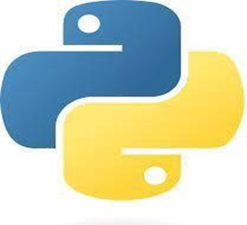

Python is an interpreted, object-oriented, high-level programming language with dynamic semantics. It was created by Guido van Rossum, and released in 1991. Its high-level built in data structures, combined with dynamic typing and dynamic binding, make it very attractive for Rapid Application Development, as well as for use as a scripting or glue language to connect existing components together.

Python's simple, easy to learn syntax emphasizes readability and therefore reduces the cost of program maintenance. Python supports modules and packages, which encourages program modularity and code reuse. The Python interpreter and the extensive standard library are available in source or binary form without charge for all major platforms, and can be freely distributed.

Often, programmers fall in love with Python because of the increased productivity it provides. Since there is no compilation step, the edit-test-debug cycle is incredibly fast. Debugging Python programs is easy: a bug or bad input will never cause a segmentation fault. Instead, when the interpreter discovers an error, it raises an exception. When the program doesn't catch the exception, the interpreter prints a stack trace.

A source level debugger allows inspection of local and global variables, evaluation of arbitrary expressions, setting breakpoints, stepping through the code a line at a time, and so on. The debugger is written in Python itself, testifying to Python's introspective power. On the other hand, often the quickest way to debug a program is to add a few print statements to the source: the fast edit-test-debug cycle makes this simple approach very effective.

**It Is Used For:**

1. Data Analysis And Machine Learning

1. Web Development

1. Software Development

1. Automation Or Scripting
   * 1. What is Machine Learning

Machine learning is a subfield of artificial intelligence that focuses on developing algorithms and models that enable computers to learn from and make predictions or decisions based on data, without being explicitly programmed. It is a powerful tool that allows systems to automatically analyse and interpret complex patterns and relationships within datasets, uncovering valuable insights and making intelligent decisions.

At the core of machine learning is the concept of training a model using data. The model learns patterns and relationships from the training data, which can then be applied to new, unseen data to make predictions or take actions. This process involves selecting appropriate algorithms and techniques, such as linear regression, decision trees, support vector machines, or neural networks, depending on the specific problem and data characteristics.

Machine learning has numerous applications across various domains. In the field of healthcare, it can aid in diagnosing diseases, predicting patient outcomes, and developing personalized treatment plans. In finance, machine learning algorithms can be used for fraud detection, risk assessment, and algorithmic trading. In marketing, machine learning can help analyse customer behaviour, optimize advertising campaigns, and recommend personalized products or services.

The availability of large datasets and advances in computational power have significantly contributed to the growth and success of machine learning. The field has also benefited from open-source libraries and frameworks, such as TensorFlow, PyTorch, and scikit-learn, which provide powerful tools and algorithms to simplify the development and deployment of machine learning models.

As technology continues to advance, machine learning is expected to play an increasingly prominent role in transforming industries and solving complex problems. From autonomous vehicles to personalized recommendations, machine learning has the potential to revolutionize the way we live and work, driving innovation and pushing the boundaries of what computers can accomplish.

* + 1. Python Using Machine Learning

Python is an immensely popular programming language that has revolutionized the field of machine learning. Its versatility, simplicity, and extensive libraries make it the preferred choice for developing sophisticated machine learning models. Python's wide range of libraries, such as TensorFlow, Kera’s, and scikit-learn, provide powerful tools for building, training, and deploying machine learning algorithms.

With Python, developers can effortlessly handle complex mathematical computations and efficiently manipulate large datasets. Its intuitive syntax and vast community support make it easier to implement various machine learning algorithms, including decision trees, support vector machines, neural networks, and ensemble methods. Python's ability to integrate seamlessly with other technologies and frameworks allows for the development of comprehensive machine learning pipelines.

Moreover, Python's data visualization libraries, such as Matplotlib and seaborn, enable analysts to explore and present data in a visually appealing and meaningful way. These libraries facilitate the creation of insightful visualizations, aiding in the interpretation of machine learning models and their results.

Python's machine learning ecosystem also benefits from its extensive collection of open-source contributions. The availability of pre-trained models and readily accessible datasets allows developers to rapidly prototype and experiment with different algorithms, saving time and effort.

1. Platform Introduction

PyCharm

1. What is PyCharm

PyCharm is an integrated development environment (IDE) specifically designed for Python programming. Developed by JetBrains, PyCharm provides a comprehensive set of tools and features that enhance productivity and streamline the development process for Python projects.

One of PyCharm's key strengths is its user-friendly interface, which offers a clean and intuitive environment for coding. It provides advanced code completion, syntax highlighting, and error detection, helping developers write clean and error-free code. PyCharm's intelligent code analysis can also identify potential issues and suggest improvements, saving time and effort in debugging. PyCharm offers powerful debugging capabilities, allowing developers to step through their code, inspect variables, and identify and fix errors efficiently. It supports different debugging modes, including remote debugging, making it easier to debug applications running on remote servers or devices.

The IDE also offers seamless integration with version control systems like Git, enabling developers to easily manage and track changes to their codebase. It provides features like commit, branch management, and conflict resolution, making collaborative development smooth and efficient. PyCharm provides a wide range of productivity-enhancing features. It supports code refactoring, which enables developers to make changes to their codebase while maintaining its functionality. It also offers built-in tools for code documentation, testing, and virtual environments, making it easier to manage project dependencies and run unit tests.

Another notable feature of PyCharm is its extensive plugin ecosystem. Developers can extend the functionality of the IDE by installing additional plugins for specific frameworks, libraries, or tools. This flexibility allows for customization and tailoring of PyCharm to suit specific project requirements.

PyCharm also offers strong support for web development with Django, Flask, and other Python web frameworks. It provides templates, code generators, and other tools to facilitate the creation and maintenance of web applications.

* 1. PyCharm Tools

1. **Code Editor:** PyCharm's code editor offers features like syntax highlighting, code completion, and error detection, making it easier to write clean and error-free code for emotion detection algorithms. The editor helps developers efficiently implement machine learning or deep learning models and preprocess data.
2. **Debugging Tools:** PyCharm's powerful debugger allows developers to step through their code, inspect variables, and identify and fix issues in the emotion detection software. Debugging tools aid in troubleshooting and improving the accuracy and reliability of the emotion detection algorithms.
3. **Version Control Integration:** Emotion detection software development often involves collaborative work, and PyCharm's seamless integration with version control systems like Git helps manage code changes and enables smooth collaboration among team members. Version control tools assist in tracking modifications and coordinating development efforts.
4. **Data Visualization:** PyCharm supports various data visualization libraries such as Matplotlib and seaborn. These tools enable developers to visualize emotions and their corresponding data patterns, helping them gain insights, analyse results, and present findings effectively.
5. **Unit Testing:** PyCharm includes built-in tools for writing and running unit tests, which are crucial for ensuring the accuracy and reliability of the emotion detection software. Unit testing frameworks like pytest or unit test can be utilized to validate individual components of the system and ensure they function as intended.
6. **Documentation Tools:** Emotion detection software often requires comprehensive documentation to facilitate understanding and further development. PyCharm provides integrated documentation tools that assist in documenting code, functions, classes, and methods. This helps developers maintain clear and informative documentation for their software.
7. **Profiling and Performance Optimization:** PyCharm's performance profiling tools can be used to analyse the runtime behaviour of the emotion detection software, identify performance bottlenecks, and optimize the code. Profiling tools help ensure efficient and fast execution, improving the overall performance of the software.

CHAPTER-3 SPECIFICATION OF PROJECT

3.1 Purpose Of Project

3.1.1 Scope

3.1.2 General Description

3.1.3 Project Function

1. Purpose Of The Project

The main motive of this system is to develop an automatic sign gesture detection system which will continue to possess an important role in computer vision and patter recognition.

Sign language detection plays an important role in computer vision. Nonverbal communication methods such as facial expressions, eye movement and gestures are used in many applications of human computer interaction. The motivation to create this project has many sources:

* Interest to develop a Deep Learning based project.
* I have always had a strong desire for continuous learning, and I saw deep learning as a new challenge and opportunity for growth.
* I see deep learning as a tool that can augment human capabilities, translating theory into practice to solve real problems with human-centred values.
* To gain expertise using python, OpenCV, Media pipe, etc.

1. Scope

* Translating sign language into spoken or written text in real-time, aiding communication between deaf and hearing individuals.
* Assisting in the education of sign language learners by providing instant feedback and interactive learning experiences.
* Improving accessibility in public spaces, such as airports and customer service centres, through automated sign language interpreters.
* Incorporating sign language recognition into AI personal assistants to make them accessible to the deaf community.
* Enabling content creators to include sign language translations in videos and multimedia presentations.

1. General Description

This Software provides a complete Solution for Sign language detection System using Deep Learning methods where a user can recognize the gesture of the Target public and then use that data accordingly.

Our system is Easy and Different from others. User only need to run the code by choosing from the given option with a single Click and the work will be done by Deep Learning Libraries, Sign language detection is Trained on Specified Datasets and other basic Python Programming.

At last, all the recognized text will be shown to the user on the GUI or he can also use audio output according to his own will.

The general process of SLR involves the following steps:

1. **Input Acquisition:** The system initiates by capturing input exclusively through the webcam. This live feed serves as the primary source of data for the project.
2. **Hand Detection:** The system utilizes computer vision techniques is used to detect and track hand gestures in real-time. This process involves identifying where the hands are located, how they move, and their shape within the video frames.
3. **Feature Extraction:** Subsequently, hand detection model generates hand landmarks, comprising key points on the hand. These landmarks serve as the basis for extracting relevant features, such as the positions of specific points on the hand, the overall shape of the hand, or the trajectory of hand movements.
4. **Gesture Classification:** A Machine learning algorithm is used to analyze the extracted features. Trained on a dataset of sign language gestures.
5. **Text Generation:** Upon classifying a gesture, the system generates the corresponding text representation of the sign language gesture. This could involve mapping each recognized gesture to a predefined text or symbol.
6. **Text-to-Speech Conversion:** To make the interpretation accessible to non-signing individuals, the generated text is converted into audible speech.
7. Project Function

The function of a Sign Language Recognition (SLR) project can vary depending on the specific goals and requirements. Here are some common functions that an SLR project can fulfil:

1. Sign Language Detection: The SLR system should be able to detect and locate hands in images or video frames. It should accurately identify the region of the image where the hand is located, regardless of variations in size, angle, or lighting conditions.
2. Sign Language Recognition: The SLR system should have the capability to recognize and extract the features from the hand. It should accurately interpret the gesture in the image, considering different hand size.
3. Gesture Segmentation: The SLR system should segment the individual gesture in the image or video, separating them from the background and other elements. It should accurately identify and isolate each gesture, ensuring proper recognition and interpretation.
4. Real-time Processing: Depending on the application, the SLR system may need to operate in real-time, processing incoming video streams or images on the fly. This enables immediate responses and actions based on the recognized Gesture.
5. User Interface and Visualization: The SLR system may include a user interface that allows users to interact with the system, configure settings, and view the converted Text.
6. Output in Audio Format: The SLR system not only converts sign language into text but also offers text-to-speech, turning written words into clear, natural-sounding audio. This makes communication more accessible and effective for everyone involved.

CHAPTER-4 INTRODUCTION TO TECHNOLOGIES

4.1 Introduction To Technology

4.2 Technology Used

4.2.1 Computer Vision

4.2.2 Image Processing

4.2.3 Object Detection

4.2.4 Text To Speech

4.2.5 Machine Learning

4.2.6 Pattern Recognition

1. Introduction To Technology

Technology refers to the practical application of scientific knowledge and tools to create solutions, improve efficiency, and enhance human capabilities. It encompasses a broad range of techniques, processes, and systems used to develop, produce, and utilize various products, services, and advancements.

Technology plays a vital role in shaping and transforming society, industries, and everyday life. It has revolutionized communication, transportation, healthcare, education, entertainment, and many other aspects of human existence. From the invention of the wheel and the development of agriculture to the advancements in artificial intelligence and robotics, technology has continually driven progress and innovation.

1. Technology Used

In a Sign Language Recognition (SLR) system, various technologies are used to enable accurate detection, recognition, and processing of Sign language. Here are some key technologies commonly used in SLR systems.

* 1. Computer Vision

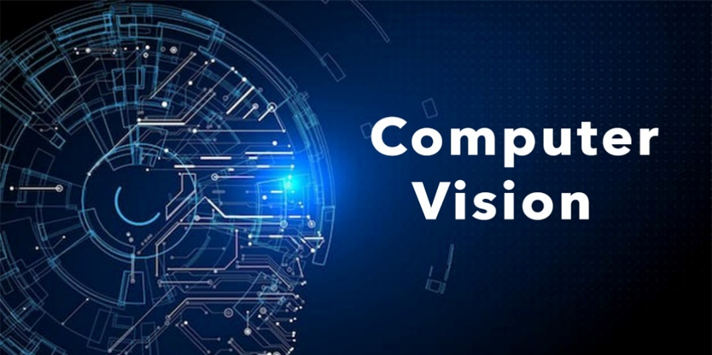

Figure 4.1 Computer Vision

Computer vision techniques are used to analyse and process images or video frames captured by cameras or sensors. These techniques involve tasks such as image preprocessing, edge detection, contour analysis, feature extraction, and object recognition, which are fundamental for license plate detection and segmentation.

Computer vision is a field of study that focuses on enabling computers to gain a high-level understanding from digital images or videos. It involves developing algorithms and techniques that allow machines to extract meaningful information from visual data, similar to how humans perceive and interpret the visual world.

Computer vision algorithms typically involve processing and analysing images or videos to extract features, recognize objects, detect patterns, and understand the spatial relationships between objects. These algorithms utilize various techniques, such as image filtering, segmentation, feature extraction, object recognition, motion analysis, and 3D reconstruction.

Computer vision relies on various techniques and technologies, including image processing, pattern recognition, machine learning, deep learning, and neural networks. The availability of large datasets, advances in computational power, and the development of sophisticated algorithms have significantly accelerated the progress in computer vision research and applications.

* + 1. Image Processing

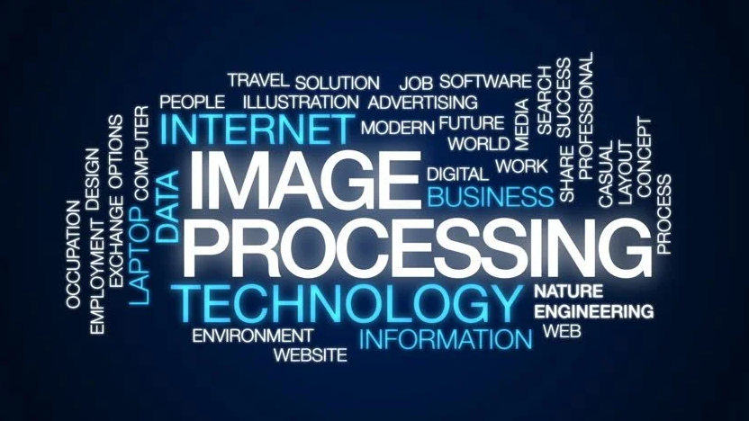

Figure 4.2 Image Processing

Image processing algorithms are utilized to enhance image quality, reduce noise, adjust contrast and brightness, and perform other necessary operations to improve the clarity and readability of license plate images. Image processing is a method to perform some operations on an image, in order to get an enhanced image or to extract some useful information from it. It is a type of signal processing in which input is an image and output may be image or characteristics/features associated with that image. Nowadays, image processing is among rapidly growing technologies. It forms core research area within engineering and computer science disciplines too.

There are two types of methods used for image processing namely, analogue and digital image processing. Analogue image processing can be used for the hard copies like printouts and photographs. Image analysts use various fundamentals of interpretation while using these visual techniques. Digital image processing techniques help in manipulation of the digital images by using computers. The three general phases that all types of data have to undergo while using digital technique are pre-processing, enhancement, and display, information extraction.

Image processing is a way to convert an image to a digital aspect and perform certain functions on it, in order to get an enhanced image or extract other useful information from it. It is a type of signal time when the input is an image, such as a video frame or image and output can be an image or features associated with that image. Usually, the AWS Image Processing System includes treating images as two equal symbols while using the set methods used. It is one of the fastest growing technologies today, with its use in various business sectors. Graphic Design forms the core of the research space within the engineering and computer science industry as well.

* + 1. Object Detection

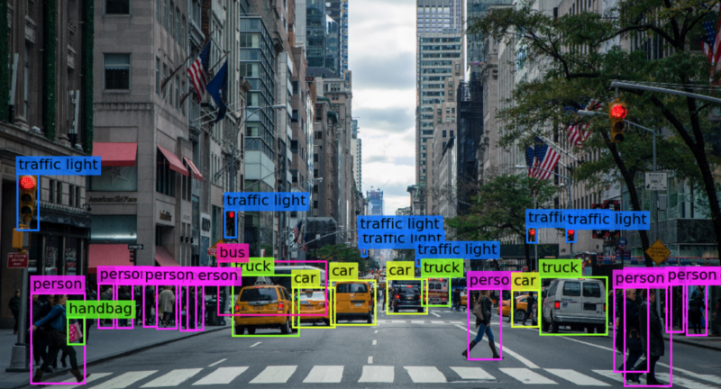

Figure 4.3 Object Detection

Over the past decade, Deep learning has drawn much greater attention and become imperious technology in the Artificial intelligence area. Object detection is considered one of the noteworthy areas in the deep learning and Computer vision. Object detection has been determined the numerous applications in computer vision such as object tracking, retrieval, video surveillance, image captioning, Image segmentation, Medical Imagine and several greater number other applications as well.

Object detection is a computer vision task that identifies and locates objects within images or videos, drawing bounding boxes around them. It not only recognizes objects but also determines their positions. Object detection algorithms analyse image features and patterns to identify objects, using techniques like machine learning and deep learning. These algorithms are trained on large datasets of labelled images to detect and classify objects in new visual inputs. Recent advancements in deep learning, particularly convolutional neural networks (CNNs) and models like Faster R-CNN, YOLO (You Only Look Once), and SSD (Single Shot MultiBox Detector), have significantly improved the accuracy and efficiency of object detection, expanded its applications and advanced the field of computer vision.

Computer vision has advanced considerably but is still challenged in matching the precision of human perception. This article belongs to computer vision. Here we will learn from scratch. It can be challenging for beginners to distinguish between different related computer vision tasks. Humans can easily detect and identify objects present in an image. The human visual system is fast and accurate and can perform complex tasks like identifying multiple objects and detecting obstacles with little conscious thought. With the availability of large amounts of data, faster GPUs, and better algorithms, we can now easily train computers to detect and classify multiple objects within an image with high accuracy.

* + 1. 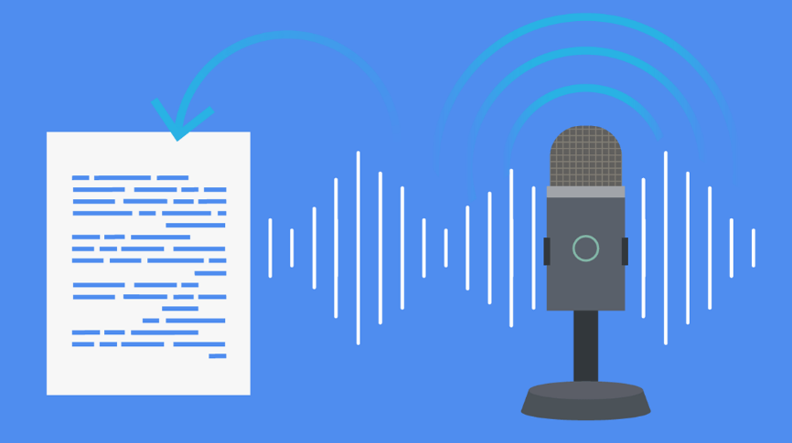Text To Speech

Figure 4.4 Text to Speech

Text-to-speech (TTS) technology transforms written text into spoken words, enabling computers and devices to communicate verbally with users. It leverages natural language processing and speech synthesis to produce human-like speech from text input, significantly improving accessibility, user experience, and automation in various fields. TTS systems first analyse the text through preprocessing steps, such as cleaning and formatting, and linguistic analysis, which examines syntax, semantics, and prosody. The speech synthesis process then uses different methods: concatenative synthesis, which pieces together recorded speech segments; parametric synthesis, which employs mathematical models to generate sound waves; and neural TTS, which utilizes deep learning models for more natural and expressive speech.

TTS technology finds applications in numerous areas, including assisting visually impaired individuals by reading aloud text from screens and printed materials, powering voice interactions in digital assistants like Siri, Alexa, and Google Assistant, and enhancing educational tools by providing spoken versions of textbooks and language lessons. It also automates customer service in call centres and chatbots, improves efficiency, and offers voice-overs for audiobooks, video games, and other multimedia content.

The benefits of TTS are vast, making digital content accessible to those with visual impairments or reading difficulties, enabling multitasking by allowing users to listen to text while engaged in other activities, and offering customizable voices and languages to suit diverse preferences and needs. However, challenges remain, such as achieving highly natural and expressive speech, especially for tonal languages and complex intonations, improving context understanding, and expanding the range of voices to include various accents, dialects, and speaking styles. Despite these challenges, advancements in artificial intelligence and machine learning continue to drive TTS technology forward, promising increasingly realistic and versatile applications in the future.

* + 1. 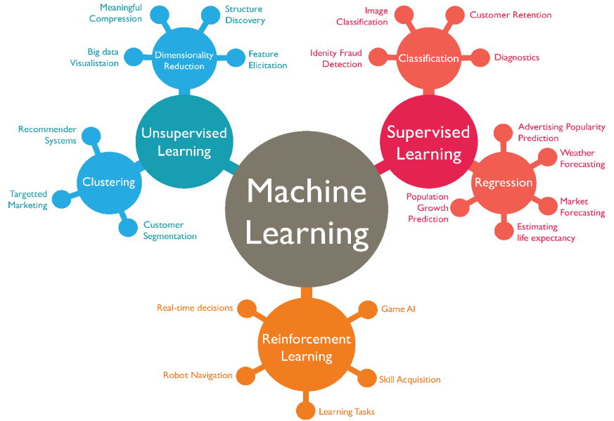Machine Learning

Figure 4.5 Machine Learning

Machine learning is a subfield of artificial intelligence that focuses on developing algorithms and models that enable computers to learn from and make predictions or decisions based on data, without being explicitly programmed. It is a powerful tool that allows systems to automatically analyse and interpret complex patterns and relationships within datasets, uncovering valuable insights and making intelligent decisions. At the core of machine learning is the concept of training a model using data.

Machine learning has numerous applications across various domains. In the field of healthcare, it can aid in diagnosing diseases, predicting patient outcomes, and developing personalized treatment plans. In finance, machine learning algorithms can be used for fraud detection, risk assessment, and algorithmic trading. In marketing, machine learning can help analyse customer behaviour, optimize advertising campaigns, and recommend personalized products or services.

The availability of large datasets and advances in computational power have significantly contributed to the growth and success of machine learning. The field has also benefited from open-source libraries and frameworks, such as TensorFlow, PyTorch, and scikit-learn, which provide powerful tools and algorithms to simplify the development and deployment of machine learning models.

As technology continues to advance, machine learning is expected to play an increasingly prominent role in transforming industries and solving complex problems. From autonomous vehicles to personalized recommendations, machine learning has the potential to revolutionize the way we live and work, driving innovation and pushing the boundaries of what computers can accomplish.

* + 1. Pattern Recognition

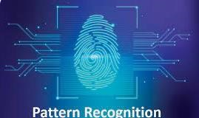

Figure 5.6 Pattern Recognition

Patterns are everywhere. It belongs to every aspect of our daily lives. Starting from the design and colour of our clothes to using intelligent voice assistants, everything involves some kind of pattern. When we say that everything consists of a pattern or everything has a pattern, the common question that comes up to our minds is, what is a pattern? How can we say that it constitutes almost everything and anything surrounding us? How can it be implemented in the technologies that we use every day?

Well, the answer to all these questions is one of the simplest things that all of us have probably been doing since childhood. When we were in school, we were often given the task of identifying the missing alphabets to predict which number would come in a sequence next or to join the dots for completing the figure. The prediction of the missing number or alphabet involved analysing the trend followed by the given numbers or alphabets. This is what pattern recognition in Machine Learning means.

Pattern recognition methods are utilized to identify and interpret the specific patterns and structures of license plates. These techniques can distinguish license plate characters from the surrounding background and other elements, aiding in accurate recognition.

Pattern recognition is a field of study that focuses on the identification and analysis of patterns in data. It involves the development of algorithms, techniques, and models to automatically detect, classify, and interpret patterns within various types of data, such as images, signals, text, and numerical data.

The goal of pattern recognition is to extract meaningful information or knowledge from data by identifying recurring structures or patterns. These patterns can be characterized by specific features, relationships, or statistical properties. By recognizing and understanding patterns, we can gain insights, make predictions, and make informed decisions in various domains.

CHAPTER-5 INTRODUCTION TO LIBRARIES

5.1 Introduction To Libraries

5.2 Libraries Used

5.2.1 NumPy

5.2.2 Media pipe

5.2.3 Sklearn

5.2.4 OpenCV

5.2.5 Tkinter

5.2.6 Pyttsx3

* 1. Introduction To Libraries

Libraries play a crucial role in software development by providing pre-written code and functions that can be used to perform specific tasks or solve specific problems. They allow developers to leverage existing solutions, save time, and build upon the work of others. In the context of Python programming, there are numerous libraries available that cater to different domains and requirements.

**Here Are Some Commonly Used Libraries In Python:**

1. **NumPy:** NumPy (Numerical Python) is a fundamental library for scientific computing in Python. It provides efficient numerical operations on multi-dimensional arrays, along with a collection of mathematical functions. NumPy is widely used for tasks such as numerical computations, linear algebra, statistics, and data manipulation.
2. **Pandas:** Pandas is a powerful library for data manipulation and analysis. It provides data structures like Data Frames for handling structured data, along with functions for data cleaning, transformation, and analysis. Pandas is extensively used in data science, machine learning, and data-driven applications.
3. **Matplotlib:** Matplotlib is a popular plotting library that enables the creation of static, animated, and interactive visualizations. It offers a wide range of plot types, customization options, and high-quality output formats. Matplotlib is commonly used for data visualization, scientific plotting, and creating charts and graphs.
4. **TensorFlow and PyTorch:** TensorFlow and PyTorch are two widely used libraries for deep learning and machine learning. They provide a comprehensive set of tools and functionalities for building and training neural networks. These libraries facilitate tasks such as image classification, natural language processing, and generative modelling.
5. **Scikit-learn:** Scikit-learn is a machine learning library that offers a wide range of algorithms and tools for various tasks, including classification, regression, clustering, and dimensionality reduction. It provides a consistent API and is widely used for building machine learning models and performing predictive analytics.
6. **OpenCV:** OpenCV (Open-Source Computer Vision Library) is a computer vision library that offers a rich set of tools and functions for image and video processing, object detection, feature extraction, and more. OpenCV is extensively used in applications such as facial recognition, object tracking, augmented reality, and robotics.
7. **Django and Flask:** Django and Flask are web development frameworks for building web applications. They provide a set of tools, utilities, and abstractions that simplify the process of creating web-based projects. Django is a full-featured framework suitable for large-scale applications, while Flask is a lightweight framework suitable for small to medium-sized projects.
8. **Kera’s:** Kera’s is an Open-Source Neural Network library written in Python that runs on top of Theano or TensorFlow. It is designed to be modular, fast and easy to use. It was developed by François Chollet, a Google engineer. Kera’s doesn’t handle low-level computation. Instead, it uses another library to do it, called the “Backend. Kera’s is high-level API wrapper for the low-level API, capable of running on top of TensorFlow, CNTK, or Theano. Kera’s High-Level API handles the way we make models, defining layers, or set up multiple input-output models.

These are just a few examples of the many libraries available in Python. The Python ecosystem is vast and diverse, with libraries catering to various domains such as natural language processing, data visualization, network programming, and more. The choice of libraries depends on the specific requirements of your project and the tasks you need to accomplish

* 1. Libraries Used

In the context of the Sign Language Recognition (SLR) system, several libraries can be used to facilitate different aspects of the project.

* + 1. NUMPY



The NumPy package, short for Numerical Python, is a fundamental library for numerical computing in Python. It provides powerful array objects and a wide range of mathematical functions, making it an essential tool for scientific computing and data analysis.

At the core of NumPy is the Nd array (n-dimensional array) data structure. This homogeneous, multidimensional array allows for efficient storage and manipulation of large datasets. NumPy arrays are significantly faster and more memory-efficient compared to traditional Python lists, making them ideal for handling large numerical datasets and performing mathematical operations.

NumPy provides a comprehensive set of mathematical functions that operate element-wise on arrays. These functions enable users to perform a wide range of numerical computations, such as arithmetic operations, logarithmic and exponential functions, trigonometric operations, statistical calculations, and more. NumPy's optimized implementations ensure fast execution of these computations.

Another key feature of NumPy is its ability to handle broadcasting. Broadcasting is a powerful mechanism that allows arrays of different shapes to be operated on together. This enables efficient and concise computation on arrays, eliminating the need for explicit loops.

NumPy also includes advanced linear algebra functions, Fourier transforms, random number generation, and tools for integrating with C/C++ and Fortran code. It serves as a foundation for many other scientific computing libraries and frameworks in Python, such as SciPy, Pandas, and scikit-learn.

* + 1. MEDIAPIPE

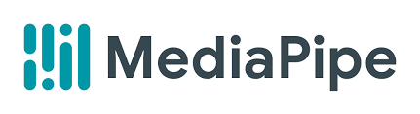

Media Pipe is an open-source framework developed by Google that facilitates the creation of multimodal machine learning pipelines, particularly excelling in real-time perception tasks. It's highly regarded for its efficiency and accuracy, making it a preferred choice for developers working on computer vision and media processing applications.

Media Pipe offers a variety of pre-built solutions, including hand tracking, face detection, pose estimation, object detection, and hair segmentation. These solutions are designed for high accuracy and real-time performance, enabling applications such as gesture recognition, facial expression analysis, augmented reality effects, and virtual try-Ons. The framework also supports multiple platforms, including Android, iOS, web browsers via Web Assembly, and desktop environments, ensuring broad accessibility and usability.

Performance is a key strength of Media Pipe, as it is optimized for real-time processing and leverages hardware acceleration to deliver efficient performance even on resource-constrained devices like mobile phones. The framework is also user-friendly, with an intuitive API and extensive documentation that cater to both beginners and experienced developers. The Python API is particularly popular for rapid prototyping and development.

Media Pipe’s applications are diverse, ranging from augmented reality and virtual try-ons to fitness apps and interactive media. In healthcare, it assists in telemedicine by analysing facial expressions and body movements for remote diagnosis and monitoring. The framework's real-time processing capability makes it suitable for interactive and live-streaming applications, while its versatility and cross-platform support ensure it can be deployed across various devices and operating systems.

* + 1. 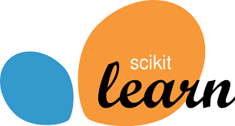SKLEARN

Scikit-learn, commonly known as sklearn, is a powerful and versatile open-source machine learning library for Python. It provides a wide array of simple yet efficient tools for data mining, data analysis, and machine learning, all built on the robust SciPy stack, which includes NumPy, SciPy, and matplotlib. Designed to be accessible to both beginners and experienced practitioners, sklearn offers a comprehensive range of supervised and unsupervised learning algorithms through a consistent and user-friendly interface.

For supervised learning, it includes classification algorithms such as Support Vector Machines (SVM), k-Nearest Neighbors (k-NN), Random Forest, Gradient Boosting, and Logistic Regression, as well as regression algorithms like Linear Regression, Ridge Regression, Lasso, and Support Vector Regression (SVR). In the realm of unsupervised learning, sklearn provides clustering techniques like k-Means, DBSCAN, and Agglomerative Clustering, alongside dimensionality reduction methods such as Principal Component Analysis (PCA), t-Distributed Stochastic Neighbour Embedding (t-SNE), and Factor Analysis.

Sklearn excels in model selection and evaluation, offering tools for cross-validation, grid search, and random search, along with metrics for assessing model performance, including accuracy, precision, recall, F1 score, and ROC-AUC. The library also includes extensive preprocessing functions for scaling, normalizing, and transforming data, as well as imputation methods for handling missing data. Its pipeline support allows users to streamline workflows by combining preprocessing steps and modelling into a single, cohesive process.

While sklearn is highly regarded for its simplicity and powerful capabilities, it does face some limitations, such as the lack of native support for deep learning models, which are better handled by libraries like TensorFlow or PyTorch, and scalability issues with very large datasets, which may require more scalable solutions like Dask-ML or Spark MLlib. Despite these challenges, sklearn remains a cornerstone of the Python machine learning ecosystem

* + 1. OPENCV

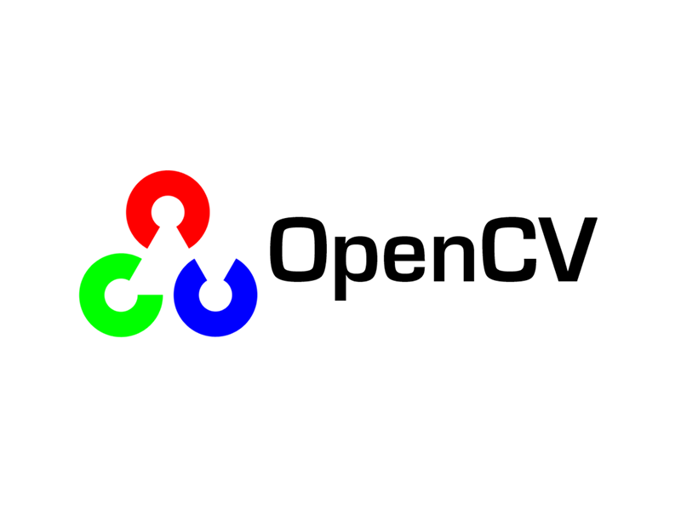

The OpenCV-python package is a powerful computer vision library for Python. It provides a wide range of functions and tools for image and video processing, object detection and tracking, and various computer vision tasks. OpenCV (Open-Source Computer Vision) is a popular open-source library that has been widely adopted in the computer vision community.

The OpenCV-python package allows users to read, manipulate, and analyse images and videos with ease. It provides functions for loading and saving images in different formats, resizing and cropping images, adjusting image properties, and applying various image processing techniques such as blurring, sharpening, edge detection, and more. These capabilities make it invaluable for tasks like image enhancement, feature extraction, and pre-processing in computer vision workflows.

Furthermore, OpenCV-python offers a range of algorithms and methods for object detection and tracking. It includes pre-trained models and functions for popular object detection frameworks like Haar cascades and deep learning-based detectors such as Single Shot MultiBox Detector (SSD) and You Only Look Once (YOLO). These models enable users to detect and track objects in images and videos, opening up possibilities for applications like face detection, object recognition, and real-time video analysis.

OpenCV has a rich set of features beyond basic image processing and object detection. It includes functions for feature detection and description, image stitching, image segmentation, motion analysis, and more. These features enable users to tackle complex computer vision problems and develop advanced applications.

* + 1. TKINTER

Tkinter is the standard GUI (Graphical User Interface) library included with Python, making it a convenient choice for developers aiming to create desktop applications. Built on the Tk GUI toolkit, Tkinter is cross-platform, allowing applications to run seamlessly on Windows, macOS, and Linux. It offers a comprehensive set of widgets such as buttons, labels, text boxes, frames, menus, and more, which can be customized and arranged to build intricate user interfaces. Tkinter's simplicity and straightforward API make it particularly appealing to beginners, while its versatility and depth also cater to the needs of experienced developers.

One of Tkinter's key strengths is its event-driven programming model, which allows applications to respond dynamically to user inputs, such as mouse clicks or keyboard events. This capability is essential for creating interactive and user-friendly applications. Moreover, Tkinter supports various layout management techniques, like pack, grid, and place, providing flexibility in designing the application layout.

Tkinter is powerful enough to support the development of sophisticated applications. It can be extended with additional Python libraries to incorporate more advanced features, such as database connectivity, network communication, and multimedia handling. Tkinter also integrates well with other standard Python libraries, enabling developers to leverage Python's extensive ecosystem to enhance their applications.

While Tkinter is highly versatile, it does have some limitations compared to more modern GUI frameworks. Its default styling and appearance can seem outdated, and it may lack some advanced features and widgets found in other libraries. However, for many applications, Tkinter's simplicity, ease of use, and out-of-the-box availability make it a practical and efficient choice for Python GUI development. At last, we can say that, Tkinter provides a robust and user-friendly way to create graphical user interfaces in Python.

* + 1. PYTTSX3

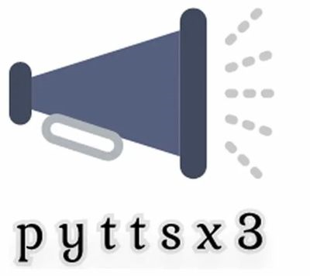

Pyttsx3 is an offline text-to-speech (TTS) library for Python, offering a reliable and efficient way to convert written text into spoken words. Unlike many other TTS solutions, pyttsx3 operates without requiring an internet connection, which makes it suitable for applications that need to function in environments with limited or no connectivity.

One of the notable features of pyttsx3 is its simplicity and ease of use. With a straightforward API, developers can quickly integrate TTS capabilities into their applications. Basic functionality such as setting the speech rate, volume, and choosing between available voices can be achieved with just a few lines of code. This ease of use makes pyttsx3 an excellent choice for beginners and those looking to add TTS features to their projects without a steep learning curve.

Moreover, pyttsx3 provides fine-grained control over speech synthesis, allowing developers to customize aspects of the speech output to suit specific needs. For instance, users can adjust the speech rate to make the spoken text faster or slower, change the volume, and select from different voices available on the system. This flexibility is beneficial for creating personalized and accessible applications, such as assistive technologies for visually impaired users, educational tools, and interactive voice-driven interfaces.

pyttsx3 does have some limitations. The quality and naturalness of the synthesized speech largely depend on the underlying TTS engine and voices available on the system, which may not be as advanced as those provided by cloud-based TTS services. In summary, pyttsx3 is a versatile and user-friendly library for adding text-to-speech functionality to Python applications.

CHAPTER-6 REQUIREMENTS

6.1 Requirements

6.1.1 Hardware Requirements

6.1.2 Software Requirements

* 1. REQUIREMENTS

Requirement definition is the process of precisely specifying the features, functions, and characteristics that a software system or project must possess in order to meet the needs of its stakeholders. It involves gathering, analysing, and documenting the requirements in a clear and unambiguous manner.

* 1. Hardware Requirements

**PROCESSOR**

A processor from AMD or Intel with at least a Core i3 is required. This ensures that the device can handle sign language conversion applications, and multitasking without significant lag.

**RAM**

A minimum of 4GB of RAM is necessary to support the running of multiple threads in the applications simultaneously, including a camera, gesture mapping and sentence generation.

**CAMERA OR WEBCAM**

A built-in or external camera capable of capturing live video is essential for recognizing gestures in real time. The camera should have a resolution sufficient to produce clear and visible video.

**SPEAKERS OR HEADPHONES**

Functional speakers or headphones are required for listening to the output in audio format. Headphones are particularly recommended to minimize background noise and improve audio clarity.

* 1. Software Requirements

**OPERATING SYSTEM**

Your device should be running Windows operating system version 8 or above to ensure compatibility with the required software tools and libraries.

**INTEGRATED DEVELOPMENT ENVIRONMENT (IDE)**

Anaconda IDE provides a comprehensive environment for Python development, particularly for scientific computing and data analysis tasks. Alternatively, Visual Studio Code is a versatile and lightweight IDE suitable for various programming languages, including Python.

**MACHINE LEARNING LIBRARY**

Libraries are essential for implementing machine learning algorithms, computer vision tasks, and data manipulation in Python. OpenCV and Media Pipe offer functionalities for image and video processing, while Scikit-learn provides a wide range of machine learning algorithms. NumPy is a fundamental library for numerical computing and array operations.

**LANGUAGE**

Proficiency in Python programming language is necessary for utilizing the specified libraries and IDEs. Python's simplicity and extensive libraries make it a popular choice for data analysis, machine learning, and scientific computing tasks.

CHAPTER-7 SOFTWARE DEVELOPMENT LIFE CYCLE

7.1 SDLC Model

7.1.1 Phases Of SDLC Model

* 1. SDLC MODEL

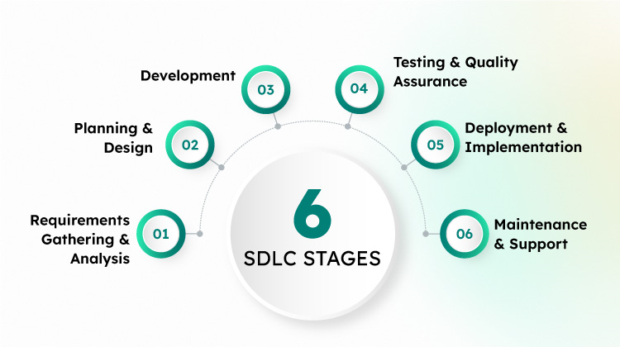System Development revolves around a life cycle that begins with the recognition of user needs. In order to develop good software, it has to go through different phases. There are various phases of the System Development Life cycle of this project. There are different models for software development, which depict these phases. We decided to use waterfall model, the oldest and the most widely used paradigm for software engineering. The various relevant stages of the System Development Life Cycle of this Application Tool are depicted in the following flow diagram.

Figure 7.1 SDLC MODEL

* + 1. PHASES OF SDLC MODEL

1. **Requirements Gathering:** In this initial phase, project stakeholders and software developers collaborate to identify and document the requirements of the software system. This involves understanding the needs of end-users, defining functional and non-functional requirements, and establishing the scope of the project.
2. **System Design:** Once the requirements are gathered, the system design phase involves creating the architecture and design of the software system. This includes defining the software components, modules, data structures, interfaces, and algorithms. The design phase helps in visualizing and planning the overall structure and behaviour of the software.
3. **Implementation:** In the implementation phase, the actual coding and development of the software system take place. Developers write the code according to the design specifications, following coding best practices and utilizing programming languages, frameworks, and tools.
4. **Testing:** The testing phase involves verifying and validating the software system to ensure its quality and reliability. Various testing techniques, such as unit testing, integration testing, system testing, and acceptance testing, are employed to identify and fix defects, validate functionality, and ensure that the software meets the specified requirements.
5. **Deployment:** Once the software passes the testing phase, it is deployed to the production environment. This involves installing the software on the target hardware or servers, configuring the necessary components, and making it available to end-users.
6. **Maintenance:** After deployment, the software enters the maintenance phase, where it is monitored, maintained, and enhanced as needed. This includes bug fixes, updates, performance optimization, and the addition of new features or functionalities based on user feedback and evolving requirements.

CHAPTER-8 SYSTEM ANALYSIS AND DESIGN

8.1 Requirement Analysis

8.1.1 Problem Recognition

8.1.2 Evaluation and Synthesis

8.1.3 Feasibility Study

8.2. System Design

8.2.1 Design Objectives

8.2.2 Working Methodology

8.2.3 Architectural Design

1. REQUIREMENT ANALYSIS

Software requirement analysis is a software-engineering task that bridges the gap between system level software allocation and software design. In the Sign Language Conversion requirement analysis was conducted in the following ways.

* Problem Recognition
* Evaluation and Synthesis
* Modelling
* Specification & Review

1. PROBLEM RECOGNITION

The concept of Sign Language Recognition is to give a computer system the ability of finding and recognising sign gestures fast precisely in images and video. Numerous algorithms and techniques have been developed for improving the performance of sign language recognition.

Recently deep learning has been highly explored for computer vision applications. Human brain can automatically and instantly detect and recognize multiple gestures. But when it comes to computer, it is very difficult to do all the challenging tasks on the level of human brain. The hand gestures are an integral part of sign language conversion.

Hand gestures are extracted and implemented through algorithms, which are efficient and some modifications are done to improve the existing algorithm models. Computers that detect and recognize hand gestures could be applied to a wide variety of practical applications.

* 1. EVALUATION AND SYNTHESIS

Problem evaluation and solution synthesis was the next major area of effort. It was in this step that all externally observable data objects, evaluation of flow and content of information was defined. System Interface characteristics were also established. Different kinds of information are gathered by the admin. The gathered information can be put in to the database.

1. FEASIBILITY STUDY

The feasibility study is carried out to test if the proposed system is worth being implemented. Given unlimited and infinite time, all projects are feasible. Unfortunately, such resources and time are not possible in real life situations hence it becomes both necessary and prudent to evaluate the feasibility of the project at the earliest possible time in order to avoid unnecessary wastage of time effort and professional embarrassment ovel an ill-conceived system.

The following feasibility studies were carried out for the proposed system: -

**Economic Feasibility**: An evaluation of development cost weighed against the income of benefit derived from the developed system. Under this section, we study the economic feasibility of the system. Whether the proposed system is economical to be developed and used in comparison to the previously used systems? If any up gradation in the hardware is required to be done for the running of the system, whether it is feasible to spend more money on the up gradation of the hardware or the software. The developed tool is open source. Thus, the tool is very economical to be implemented at any place. In addition, this tool will help in reducing the efforts required to serve the same purpose using any other application

**Technical Feasibility:** A study of function performance and constraints that may affect the ability to achieve the acceptable system. A system is technically feasible, if it can be designed and implemented within the limitations of available resources like funds, hardware, software etc. The proposed system is technically feasible because it is very easy to use this technology and the requirement of Hardware is less and can give you best performance on normal machines.

**Operational Feasibility:** Proposed System is beneficial only if it can be turned into information system that meets the organization's operating requirements. The development of the new system was started because of the requirements put forward by the management of the concerned department. So, it is sure that the system developed is operationally feasible. The availability of the required hardware, system software and technical manpower makes the system operationally feasible.

**Social Feasibility:** Survey of the feasibility is the most important part of the Feasibility Study. It is most commonly seen that the end users resist to adopt a new software. So, their option must be known. This application is also social feasible. The person only needs to have an android phone and it is an offline app thus users don’t need to have an active internet connection. Internet is required only for students.

1. SYSTEM DESIGN

The design of an information system produces the detail that state how a system will meet the requirements identified during system analysis. System specialists often refer to this stage as Logical Design, in contrast to the process of development program software, which is referred to as Physical Design.

System analysis begins process by identifying the reports and the other outputs the system will produce. Then the specific on each are pin pointed. Usually, designers sketch the form or display as they expect it to appear when the system is complete. This may be done on a paper or computer display, using one of the automated system tools available.

The system design also describes the data to be input calculated or stored. Individual data items and calculation procedure are written in detail. The procedure tells how to process the data and produce the output.

* 1. DESIGN OBJECTIVES

The following goals were kept in mind while designing the system:

* To reduce the manual work required to be done in the existing system.
* To avoid errors inherent in the manual working and hence make the outputs consistent and correct.
* To improve the management of permanent information of the Department by keeping it in properly structured tables and to provide facilities to update this information efficiently as possible.
* To make the system completely menu-driven and hence user friendly, this was necessary so that even non-programmers could use the system efficiently.
* To make the system completely compatible i.e., it should fit in the total integrated system.
* To design the system in such a way that reduced future maintenance and enhancement times and efforts.
* To make the system reliable, understandable and cost effective.
  + 1. WORKING METHODOLOGY

The working methodology of sign language detection and conversion typically involves several key steps, utilizing computer vision and machine learning techniques. Here’s a concise outline:

1. DATA COLLECTION: Dataset Preparation: Gather a large dataset of videos or images of individuals performing various sign language gestures. These datasets should be labelled with the corresponding sign language meanings.

2. PREPROCESSING:

* Frame Extraction: Extract frames from videos if the dataset is in video format.
* Normalization: Resize and normalize images to ensure consistent input dimensions and lighting conditions.
* Augmentation: Apply data augmentation techniques to increase the diversity of the training data.

3. FEATURE EXTRACTION:

* Hand Detection: Use computer vision techniques, such as Media Pipe, to detect and track hands.
* Key point Detection: Identify and extract key points of interest (e.g., finger joints, wrist, elbow) from the detected hand regions.

4. MODEL TRAINING:

* Training Dataset: Split the pre-processed data into training and validation sets.
* Model Selection: Choose an appropriate machine learning model, such as a Random Forest Classifier, Convolutional Neural Network (CNN) or Recurrent Neural Network (RNN), for gesture recognition.
* Training: Train the model on the training dataset, using the extracted features and corresponding labels.
* Evaluation: Validate the model's performance on the validation set and fine-tune hyperparameters as needed.

5. SIGN RECOGNITION:

* Real-time Detection: Implement real-time detection using a webcam or other camera devices.
* Feature Extraction: Continuously extract features from the video stream.
* Prediction: Use the trained model to predict the sign language gesture in real-time.

6. CONVERSION TO TEXT/SPEECH:

* Mapping: Map the recognized gestures to their corresponding text or speech outputs.
* Text Display: Display the recognized text on the screen.
* Text-to-Speech (Optional): Convert the recognized text into speech using a text-to-speech engine like pyttsx3 for auditory feedback.

7. USER INTERFACE: Develop a user-friendly interface to facilitate easy interaction, providing visual and/or auditory feedback.

* + - 1. Architectural Design

Architectural design involves identifying the software component, decoupling and decomposing the system into processing modules and conceptual data structures and specifying the interconnection among components.

Good notation can clarify the interrelationship and interactions if interest, while poor notation can complete and interfere with good design practice. A data flow-oriented approach was used to design the project. This includes Entity Relationship Diagram (ERD) and Data Flow Diagrams (DFD).

CHAPTER-9 RESEARCH METHODOLOGY

9.1 Flowchart

9.2 Workflow Diagram

9.3 Application Working Diagram

1. FLOWCHART

Flowchart is a diagram that depicts a process, system or computer algorithm. They are widely used in multiple fields to document, study, plan, improve and communicate often complex processes in clear, easy-to-understand diagrams.

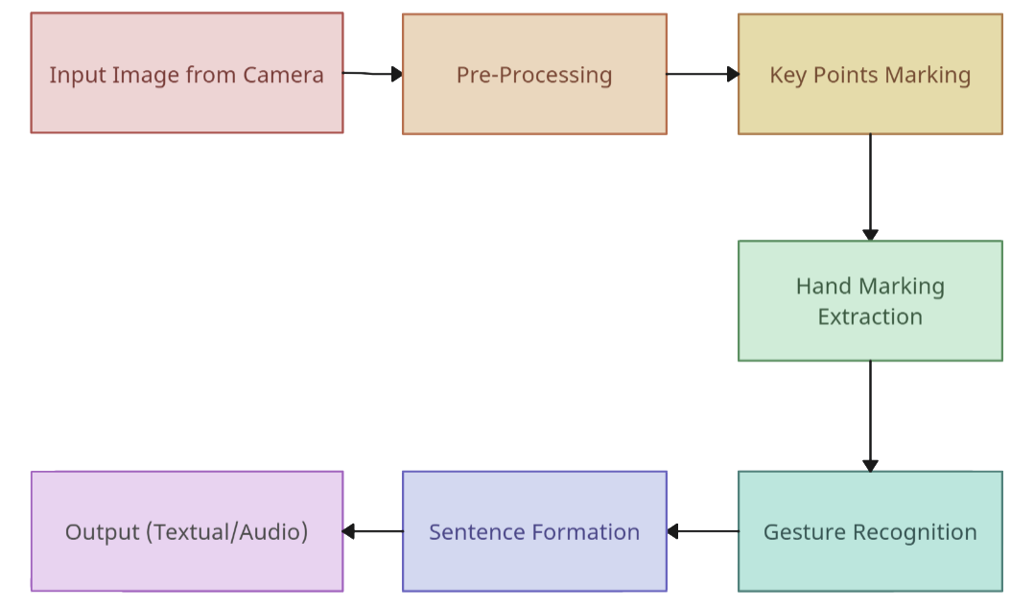

Figure 9.1 Flowchart Of SLR System

* 1. Workflow Diagram

The below diagram shows the work flow of this Project as we can see in this image an input

frame is captured from the webcam now with the python. This below proposed work flow

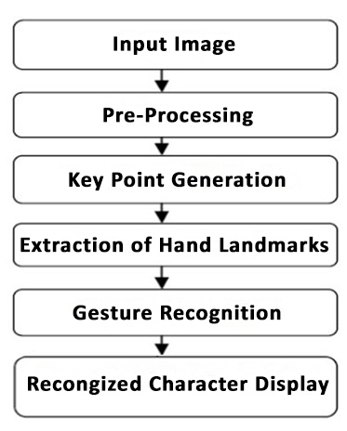diagram show the detail steps which we use to develop our system.

Figure 9.2 Work Flow Diagram of SLR System

**Steps To Develop SLR System:**

Developing a Sign Language Recognition (SLR) System involves a series of structured steps to ensure accuracy and efficiency. Below is the outline of the process:

1. Image Capture:

* Strategically place cameras in the desired location to capture images or frames effectively.
* Utilize high-resolution cameras to ensure clear and detailed image acquisition.

1. Camera Calibration and Settings:

* Optimize camera settings, including focus, exposure, and white balance, to achieve the best possible image quality.
* Perform camera calibration to correct for lens distortion and ensure accurate spatial measurements.

1. Image Preprocessing:

* Apply preprocessing techniques to the captured images or frames to enhance their quality.
* Generate hand landmarks by detecting and marking key points on the hand for further analysis.

1. Coordinate Extraction:

* Extract the coordinates of the detected hand landmarks from the pre-processed images.
* Ensure precise and consistent extraction to facilitate accurate recognition.

1. Model Training:

* Train a machine learning model using a labelled dataset of hand gestures corresponding to alphanumeric characters.
* Consider using models such as Random Forest Classifier, Convolutional Neural Network (CNN), or Support Vector Machine (SVM) for training.
* Perform rigorous validation and tuning of the model to optimize its performance.

1. Character Recognition and Classification:

* Use the trained model to recognize and classify the hand gestures into their respective alphanumeric symbols.
* Ensure real-time or near-real-time classification to support smooth user interactions.

1. Sentence Reconstruction:

* Reconstruct the recognized characters to form complete sentences.
* Implement algorithms to handle spacing, punctuation, and capitalization for coherent sentence formation.

1. Post-Processing:

* Apply post-processing techniques to improve the accuracy and reliability of the recognized text.
* Utilize error correction algorithms and language-specific constraints to minimize recognition errors.

1. Text Storage:

* Store the generated text from the recognized hand gestures in a file.
* Ensure proper file management and data integrity for future reference and analysis.

1. User Interface and Audio Output:
   * Display the recognized text in a graphical user interface (GUI) for user interaction.
   * Include an option to enable audio output, converting the recognized text into speech for accessibility.
2. Application Working Diagram

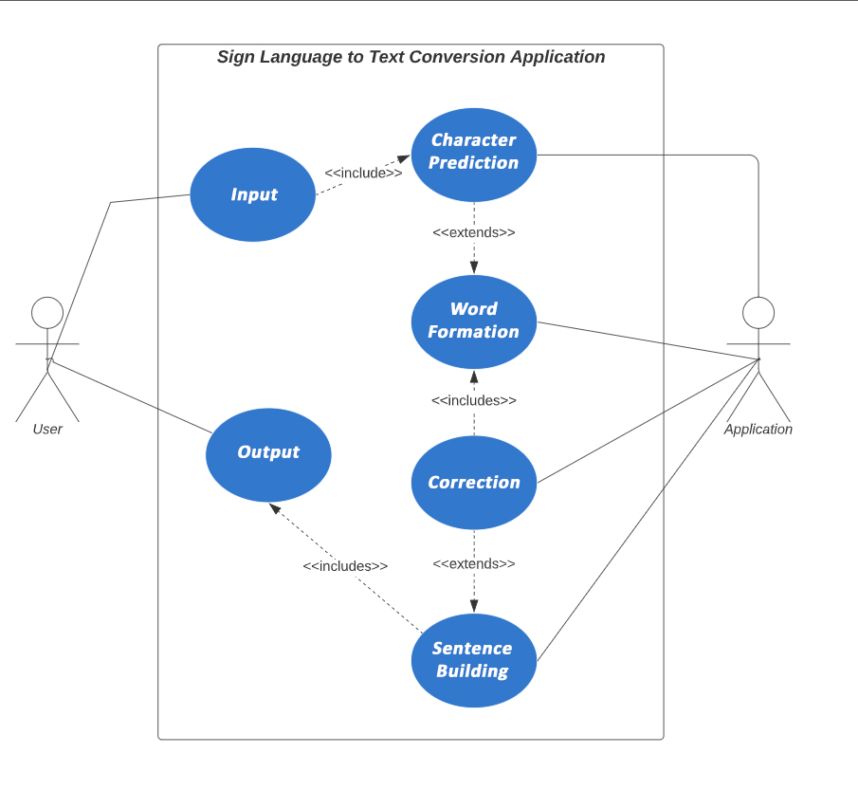

The image is a UML (Unified Modeling Language) use case diagram for a "Sign Language to Text Conversion Application." Here’s a detailed explanation of the components and their relationships:

**Actors**

1. **User**: The primary user of the application, likely someone who uses sign language.
2. **Application**: Represents the system or application itself that performs various tasks.

**Use Cases**

1. **Input**: The starting point where the user provides sign language input to the application.
2. **Character Prediction**: A process that predicts individual characters from the sign language input. It is included within the Input process.
3. **Word Formation**: The next step where predicted characters are combined to form words. This use case extends from Character Prediction, indicating that it builds upon the predicted characters.
4. **Correction**: This use case handles any necessary corrections to the formed words. It includes the Word Formation process.
5. **Sentence Building**: The final step where corrected words are put together to form sentences. This use case extends from Correction, meaning it relies on the corrected words.
6. **Output**: The result provided to the user, which includes the sentence-building process.

**Relationships**

* **Includes**: Depicted with dashed arrows and "<<includes>>" labels. This relationship shows that one use case (e.g., Input) involves the execution of another use case (e.g., Character Prediction).
* **Extends**: Shown with dashed arrows and "<<extends>>" labels. This relationship indicates that one use case (e.g., Sentence Building) extends the behavior of another use case (e.g., Correction).

**Flow of Interaction**

1. The **User** provides input to the application through the **Input** use case.
2. **Input** includes **Character Prediction**, which predicts individual characters from the sign language.
3. **Character Prediction** extends to **Word Formation**, forming words from the predicted characters.
4. **Word Formation** includes the **Correction** use case, ensuring the words are accurate.
5. **Correction** extends to **Sentence Building**, where sentences are formed from the corrected words.
6. The **Output** use case includes the **Sentence Building** process, delivering the final text output to the **User**.

CHAPTER-10 IMPLEMENTATION

10.1 Implementation

10.1.1 Steps For Implementing SLR System

1. IMPLEMENTATION

It can be defined as the procedure of developing any system. Here, in this project we are developing Sign language recognition system.

* 1. STEPS FOR IMPLEMENTING SLR SYSTEM

1. Visit the Anaconda website: Go to https://www.anaconda.com/products/individual and navigate to the Anaconda Individual Edition page.
2. Select your operating system: Choose the version of Anaconda appropriate for your operating system (Windows, macOS, or Linux). Click on the respective download button to start the download.
3. Choose Python version: On the download page, you'll have the option to choose between Python 3.7, 3.8, or 3.9. Select the Python version you prefer.
4. Download the installer: Once you have chosen your operating system and Python version, click on the "Download" button to begin the download. The file size can be substantial, so it may take some time depending on your internet speed.
5. Run the installer: After the download is complete, locate the downloaded installer file and run it. Follow the installation instructions provided by the Anaconda installer. You can choose the default installation settings or customize them according to your preferences.
6. Complete the installation: Once the installation is finished, you should have Anaconda successfully installed on your system.
7. Open Anaconda Navigator: Launch the Anaconda Navigator, which provides a graphical user interface (GUI) for managing your Python environments and packages. You can usually find the Anaconda Navigator in your applications or programs menu.
8. Create and activate an environment: In the Anaconda Navigator, you can create a new Python environment specifically for facial recognition. Click on the "Environments" tab, then click the "Create" button to create a new environment. Provide a name for the environment and choose the Python version.

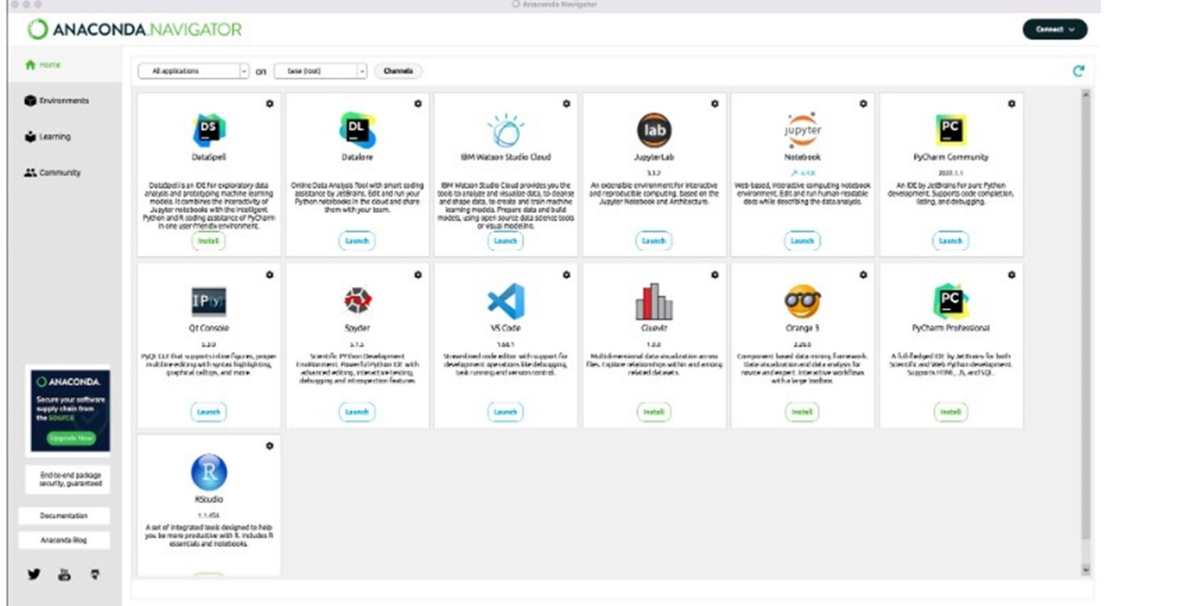

**Launch CMD.exe Prompt**

By launching command prompt, we can install different python libraries for the sign language conversion system.

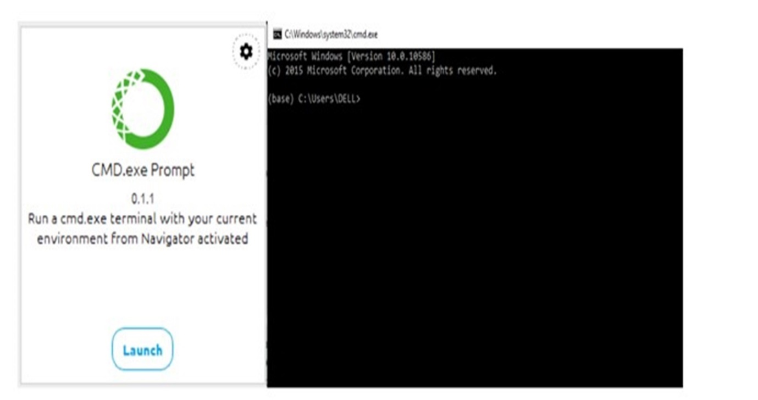

**Install Python Libraries**

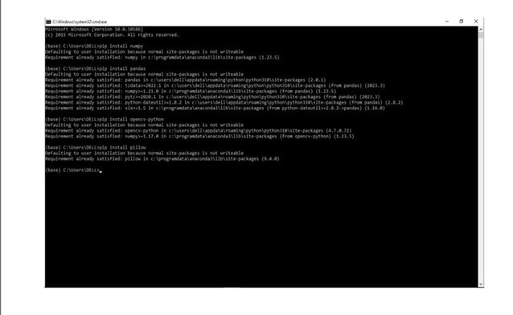Different python libraries can be installed from the command prompt by using “pip install” command.

**Platform Launch**

Launch the platform, write the coding part in it and run the required program.

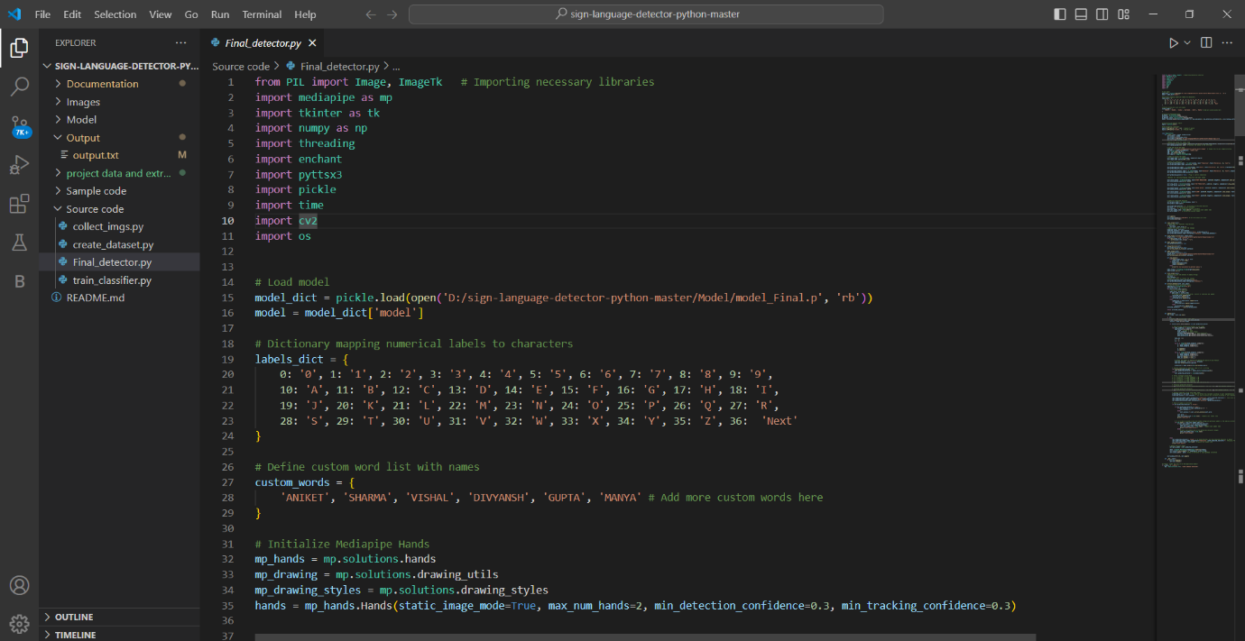

CHAPTER-11 CODING

11.1 Code For Hand Landmarking

11.2 Main File

1. CODE FOR HAND LANDMARKING

import cv2

import mediapipe as mp

mp_drawing = mp.solutions.drawing_utils

mp_drawing_styles = mp.solutions.drawing_styles

mp_hands = mp.solutions.hands

# For static images:

IMAGE_FILES = []

with mp_hands.Hands(

static_image_mode=True,

max_num_hands=2,

min_detection_confidence=0.5) as hands:

for idx, file in enumerate(IMAGE_FILES):

# Read an image, flip it around y-axis for correct handedness output (see

# above).

image = cv2.flip(cv2.imread(file), 1)

# Convert the BGR image to RGB before processing.

results = hands.process(cv2.cvtColor(image, cv2.COLOR_BGR2RGB))

# Print handedness and draw hand landmarks on the image.

print('Handedness:', results.multi_handedness)

if not results.multi_hand_landmarks:

continue

image_height, image_width, _ = image.shape

annotated_image = image.copy()

for hand_landmarks in results.multi_hand_landmarks:

print('hand_landmarks:', hand_landmarks)

print(

f'Index finger tip coordinates: (',

f'{hand_landmarks.landmark[mp_hands.HandLandmark.INDEX_FINGER_TIP].x * image_width}, '

f'{hand_landmarks.landmark[mp_hands.HandLandmark.INDEX_FINGER_TIP].y * image_height})'

)

mp_drawing.draw_landmarks(

annotated_image,

hand_landmarks,

mp_hands.HAND_CONNECTIONS,

mp_drawing_styles.get_default_hand_landmarks_style(),

mp_drawing_styles.get_default_hand_connections_style())

cv2.imwrite(

'/tmp/annotated_image' + str(idx) + '.png', cv2.flip(annotated_image, 1))

# Draw hand world landmarks.

if not results.multi_hand_world_landmarks:

continue

for hand_world_landmarks in results.multi_hand_world_landmarks:

mp_drawing.plot_landmarks(

hand_world_landmarks, mp_hands.HAND_CONNECTIONS, azimuth=5)

# For webcam input:

cap = cv2.VideoCapture(0)

with mp_hands.Hands(

model_complexity=0,

min_detection_confidence=0.5,

min_tracking_confidence=0.5) as hands:

while cap.isOpened():

success, image = cap.read()

if not success:

print("Ignoring empty camera frame.")

# If loading a video, use 'break' instead of 'continue'.

continue

# To improve performance, optionally mark the image as not writeable to

# pass by reference.

image.flags.writeable = False

image = cv2.cvtColor(image, cv2.COLOR_BGR2RGB)

results = hands.process(image)

# Draw the hand annotations on the image.

image.flags.writeable = True

image = cv2.cvtColor(image, cv2.COLOR_RGB2BGR)

if results.multi_hand_landmarks:

for hand_landmarks in results.multi_hand_landmarks:

mp_drawing.draw_landmarks(

image,

hand_landmarks,

mp_hands.HAND_CONNECTIONS,

mp_drawing_styles.get_default_hand_landmarks_style(),

mp_drawing_styles.get_default_hand_connections_style())

# Flip the image horizontally for a selfie-view display.

cv2.imshow('MediaPipe Hands', cv2.flip(image, 1))

if cv2.waitKey(5) & 0xFF == 27:

break

cap.release()

* 1. MAIN FILE

from PIL import Image, ImageTk # Importing necessary libraries

import mediapipe as mp

import tkinter as tk

import numpy as np

import threading

import enchant

import pyttsx3

import pickle

import time

import cv2

import os

# Load model

model_dict = pickle.load(open('D:/sign-language-detector-python-master/Model/model_Final.p', 'rb'))

model = model_dict['model']

# Dictionary mapping numerical labels to characters

labels_dict = {

0: '0', 1: '1', 2: '2', 3: '3', 4: '4', 5: '5', 6: '6', 7: '7', 8: '8', 9: '9',

10: 'A', 11: 'B', 12: 'C', 13: 'D', 14: 'E', 15: 'F', 16: 'G', 17: 'H', 18: 'I',

19: 'J', 20: 'K', 21: 'L', 22: 'M', 23: 'N', 24: 'O', 25: 'P', 26: 'Q', 27: 'R',

28: 'S', 29: 'T', 30: 'U', 31: 'V', 32: 'W', 33: 'X', 34: 'Y', 35: 'Z', 36: 'Next'

}

# Define custom word list with names

custom_words = {

'ANIKET', 'SHARMA', 'VISHAL', 'DIVYANSH', 'GUPTA', 'MANYA' # Add more custom words here

}

# Initialize Mediapipe Hands

mp_hands = mp.solutions.hands

mp_drawing = mp.solutions.drawing_utils

mp_drawing_styles = mp.solutions.drawing_styles

hands = mp_hands.Hands(static_image_mode=True, max_num_hands=2, min_detection_confidence=0.3, min_tracking_confidence=0.3)

# Initialize the pyttsx3 engine

engine = pyttsx3.init()

# Set properties (optional)

engine.setProperty('rate', 120) # Speed of speech

engine.setProperty('volume', 1) # Volume level

class Application:

def __init__(self, window, window_title):

self.window = window

self.window.title(window_title)

self.window.iconbitmap('D:/sign-language-detector-python-master/Images/logo.ico')

self.vid = cv2.VideoCapture(0)

# Define the canvas for camera feed

self.canvas = tk.Canvas(window, width=self.vid.get(cv2.CAP_PROP_FRAME_WIDTH), height=self.vid.get(cv2.CAP_PROP_FRAME_HEIGHT)) # can set default values also

self.canvas.place(x=10, y=20) # Position the canvas on the left side

# Load and resize the image

image_dir = 'D:/sign-language-detector-python-master/Images' # Change this to your image directory

img_path = os.path.join(image_dir, 'symbol.png')

img = Image.open(img_path)

img = img.resize((500, 482))

self.img_tk = ImageTk.PhotoImage(img)

# Label to display the image

self.image_label = tk.Label(window, image=self.img_tk)

self.image_label.place(x=670, y=18)

# Labels for prediction

self.predicted_symbol_label = tk.Label(window, text="Prediction", font=("Helvetica", 20, "bold"))

self.predicted_symbol_label.place(x=10, y=515)

self.predicted_word_label = tk.Label(window, text="Word", font=("Helvetica", 20, "bold"), wraplength=700)

self.predicted_word_label.place(x=10, y=575)

self.predicted_sentence_label = tk.Label(window, text="Sentence", font=("Helvetica", 20, "bold"), wraplength=700)

self.predicted_sentence_label.place(x=10, y=635)

self.prediction_active = False # Flag to control prediction

# Buttons for starting/stopping prediction and audio output

self.start_button = tk.Button(window, text="START PREDICTION", width=20, height=2, command=self.start_prediction, font=("Helvetica", 8, "bold"))

self.start_button.place(x=775, y=520)

self.stop_button = tk.Button(window, text="STOP PREDICTION", width=20, height=2, command=self.stop_prediction, font=("Helvetica", 8, "bold"))

self.stop_button.place(x=935, y=520)

self.audio_button = tk.Button(window, text="AUDIO OUTPUT", width=30, height=2, command=self.audio_output, font=("Helvetica", 12, "bold"))

self.audio_button.place(x=775, y=570)

self.start_button = tk.Button(window, text="CLEAR", width=20, height=2, command=self.clear_output, font=("Helvetica", 8, "bold"))

self.start_button.place(x=775, y=632)

self.reset_button = tk.Button(window, text="RESET", width=20, height=2, command=self.reset_output, font=("Helvetica", 8, "bold"))

self.reset_button.place(x=935, y=632)

# Label for predicted character

self.predict_label = tk.Label(window, text="")

self.predict_label.pack()

self.predicted_character = "" # Initialize predicted character

self.word = "" # Initialize word variable

self.sentence = "" # Initialize sentence variable

self.last_symbol_time = time.time()+5 # Initialize last symbol time

self.prev_symbol = "" # Initialize previous symbol

self.update()

self.window.geometry("1185x700") # Set the window size here

self.window.mainloop()

def clear_output(self):

# Remove the last character from the word

if self.word:

self.word = self.word[:-1]

# Update the labels to reflect the changes

predicted_word = self.word

predicted_sentence = self.sentence

self.predicted_word_label.config(text=f"Word: {predicted_word}")

self.predicted_sentence_label.config(text=f"Sentence: {predicted_sentence}")

def write_output_to_file(self, output_text):

output_file = 'D:/sign-language-detector-python-master/Output/output.txt'

with open(output_file, "w") as f:

f.write(output_text.strip() + "\n")

def start_prediction(self):

self.prediction_active = True

def stop_prediction(self):

self.prediction_active = False

self.write_output_to_file(self.sentence)

def audio_output(self):

self.prediction_active = False

output_file = 'D:/sign-language-detector-python-master/Output/output.txt'

self.write_output_to_file(self.sentence)

def play_audio():

with open(output_file, "r") as file:

output_text = file.read()

if output_text:

engine.say(output_text)

engine.runAndWait()

else:

print("No text available to generate audio.")

audio_thread = threading.Thread(target=play_audio)

audio_thread.start()

def reset_output(self):

# Reset both word and sentence to empty strings

self.word = ""

self.sentence = ""

# Update the labels to reflect the changes

self.predicted_word_label.config(text="Word:")

self.predicted_sentence_label.config(text="Sentence:")

def correct_sentence(self, user_input):

# Create an English dictionary object

english_dict = enchant.Dict("en_US")

corrected_words = []

for word in user_input.split():

# Convert word to uppercase

upper_word = word.upper()

if upper_word in custom_words:

# If match found in custom_words, convert to lowercase and append

corrected_words.append(word)

elif english_dict.check(word):

corrected_words.append(word)

else:

suggestions = english_dict.suggest(word)

if suggestions:

corrected_words.append(suggestions[0])

else:

corrected_words.append(word)

corrected_sentence = ' '.join(corrected_words)

return corrected_sentence

def update(self):

ret, frame = self.vid.read()

if ret:

# frame = cv2.resize(frame, (700, 400))

frame = cv2.cvtColor(frame, cv2.COLOR_BGR2RGB)

results = hands.process(frame)

if results.multi_hand_landmarks and self.prediction_active:

# Draw the hand annotations/landmark on the image.

for hand_landmarks in results.multi_hand_landmarks:

mp_drawing.draw_landmarks(

frame, # image to draw

hand_landmarks, # model output

mp_hands.HAND_CONNECTIONS, # hand connections

mp_drawing_styles.get_default_hand_landmarks_style(),

mp_drawing_styles.get_default_hand_connections_style())

data_aux = []

x_ = []

y_ = []

for i in range(len(hand_landmarks.landmark)):

x = hand_landmarks.landmark[i].x

y = hand_landmarks.landmark[i].y

x_.append(x)

y_.append(y)

for i in range(len(hand_landmarks.landmark)):

x = hand_landmarks.landmark[i].x

y = hand_landmarks.landmark[i].y

data_aux.append(x - min(x_))

data_aux.append(y - min(y_))

# Double the number of features by adding the square of each feature

data_aux_squared = [x**2 for x in data_aux]

data_aux.extend(data_aux_squared)

prediction = model.predict([np.asarray(data_aux)])

# Convert prediction to numerical label if it's a string

if isinstance(prediction[0], str):

self.predicted_character = labels_dict[int(prediction[0])]

else:

self.predicted_character = int(prediction[0])

# # Draw rectangle around hand

# x1 = int(min(x_) * frame.shape[1]) - 10

# y1 = int(min(y_) * frame.shape[0]) - 10

# x2 = int(max(x_) * frame.shape[1]) - 10

# y2 = int(max(y_) * frame.shape[0]) - 10

# cv2.rectangle(frame, (x1, y1), (x2, y2), (0, 0, 0), 4)

# # Display predicted character

# cv2.putText(frame, str(self.predicted_character), (x1, y1 - 10), cv2.FONT_HERSHEY_SIMPLEX, 1.3, (0, 0, 0), 3, cv2.LINE_AA)

# # Display predicted character

# cv2.putText(frame, str(self.predicted_character), (10, 50), cv2.FONT_HERSHEY_SIMPLEX, 1.3, (0, 0, 0), 3, cv2.LINE_AA)

# Display predicted string with label names

predicted_word = self.word # You need to define this variable according to your implementation

predicted_sentence = self.sentence # You need to define this variable according to your implementation

self.predicted_symbol_label.config(text=f"Prediction: {self.predicted_character}") # Use self.predicted_character here

self.predicted_word_label.config(text=f"Word: {predicted_word}")

self.predicted_sentence_label.config(text=f"Sentence: {predicted_sentence}")

# Check if symbol is not blank

if self.predicted_character != "Blank":

if self.predicted_character == "Next":

if self.sentence and self.sentence[-1] != " ":

self.sentence += " "

else:

self.sentence += self.correct_sentence(self.word)

self.word = ""

self.last_symbol_time = time.time() # Update last symbol time

print("reset_next")

# If it's been 3 seconds since last symbol change and previous symbol is the same as current symbol, add symbol to word

if time.time() - self.last_symbol_time >= 3:

if self.prev_symbol == self.predicted_character:

self.word += str(self.predicted_character)

self.last_symbol_time = time.time() # Update last symbol time

print("reset_symbol_match")

else:

# Reset last_symbol_time if the predicted character changes

self.last_symbol_time = time.time()

print("reset_change")

else:

self.predicted_character = "Blank" # No hand detected, set the predicted character to blank

self.predicted_symbol_label.config(text=f"Prediction: {self.predicted_character}") # Display "Blank" in symbol label

self.last_symbol_time = time.time() # Update last symbol time

print("reset_blank")

# Update previous symbol

self.prev_symbol = self.predicted_character

photo = ImageTk.PhotoImage(image=Image.fromarray(frame))

self.canvas.create_image(0, 0, image=photo, anchor=tk.NW)

self.canvas.photo = photo # Keep a reference to avoid garbage collection

self.window.after(10, self.update)

def __del__(self):

if self.vid.isOpened():

self.vid.release()

# Create a window and pass it to the Application object

if __name__ == '__main__':

App = Application(tk.Tk(), "SIGN LANGUAGE DETECTOR")

CHAPTER-12 TESTING & RESULT

12.1 Testing

12.2 Result For SLR System

1. TESTING

Software testing is the process of evaluating and verifying that a software product or application does what it is supposed to do. The benefits of testing include preventing bugs, reducing development costs and improving performance. Software testing arrived alongside the development of software, which had its beginnings just after the Second World War. Computer scientist Tom Kilburn is credited with writing the first piece of software, which debuted on June 21, 1948, at the University of Manchester in England. It performed mathematical calculations using machine code instructions.

Debugging was the main testing method at the time and remained so for the next two decades. By the 1980s, development teams looked beyond isolating and fixing software bugs to testing applications in real-world settings. It set the stage for a broader view of testing, which encompassed a quality assurance process that was part of the software development life cycle.

Software testing has traditionally been separated from the rest of development. It is often conducted later in the software development life cycle after the product build or execution stage. A tester may only have a small window to test the code – sometimes just before the application goes to market. If defects are found, there may be little time for recoding or retesting. It is not uncommon to release software on time, but with bugs and fixes needed. Or a testing team may fix errors but miss a release date. A good testing approach encompasses the application programming interface (API), user interface and system levels. As well, the more tests that are automated, and run early, the better.

Though testing itself costs money, companies can save millions per year in development and support if they have a good testing technique and QA processes in place. Early software testing uncovers problems before a product goes to market.

There are many different types of software tests, each with specific objectives and strategies:

1. Acceptance testing: Verifying whether the whole system works as intended.
2. Integration testing: Ensuring that software components or functions operate together.
3. Unit testing: Validating that each software unit performs as expected. A unit is the smallest testable component of an application.
4. Functional testing: Checking functions by emulating business scenarios, based on functional requirements. Black-box testing is a common way to verify functions.
5. Performance testing: Testing how the software performs under different workloads. Load testing, for example, is used to evaluate performance under real-life load conditions.

Major types of testing are as follows:

1. **Unit Testing**: Unit testing is the first level of functional testing in order to test any software. In this, the test engineer will test the module of an application independently or test all the module functionality is called unit testing. The primary objective of executing the unit testing is to confirm the unit components with their performance. Here, a unit is defined as a single testable function of software or an application. And it is verified throughout the specified application development phase.
2. **Integration Testing**: Once we are successfully implementing the unit testing, we will go integration testing. It is the second level of functional testing, where we test the data flow between dependent modules or interface between two features is called integration testing. The purpose of executing the integration testing is to test the statement's accuracy between each module.
3. **Performance Testing**: In performance testing, the test engineer will test the working of an application by applying some load. In this type of non-functional testing, the test engineer will only focus on several aspects, such as Response time, Load, scalability, and Stability of the software or an application.
4. **System Testing**: Whenever we are done with the unit and integration testing, we can proceed with the system testing. In system testing, the test environment is parallel to the production environment. It is also known as end-to-end testing. In this type of testing, we will undergo each attribute of the software and test if the end feature works according to our requirement and analyse the software product as a complete system.
   1. RESULT FOR SLR SYSTEM

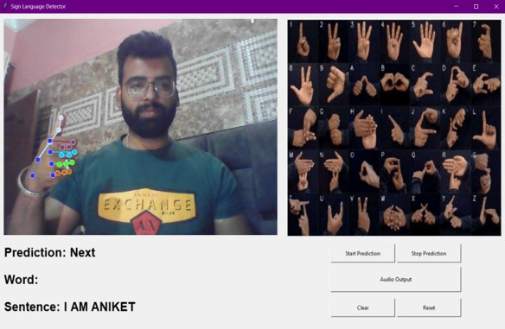

Figure 12.2.1 Alphabetic Sentence Generation

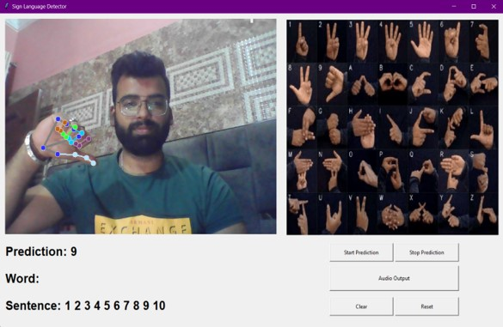

Figure 12.2.2 Counting Sentence Generation

CHAPTER-13 CONCLUSION AND FUTURE SCOPE

13.1 Conclusion

13.2 Future Scope

1. CONCLUSION

Sign Language Recognition (SLR) systems are an essential technology that enables the automated detection, extraction, and recognition of hand gestures from images or video frames. SLR systems have various applications, including enhancing communication for individuals with hearing impairments, facilitating sign language learning, and promoting inclusivity in diverse settings.

The development of an SLR system involves the integration of multiple components, including image capture, preprocessing, hand landmark detection, coordinate extraction, model training, character recognition, sentence reconstruction, post-processing, and data storage. These components work together to accurately detect hand gestures, extract coordinates, recognize the gestures using machine learning techniques, and store the recognized text for further use.

Python is a popular programming language used for implementing SLR systems due to its ease of use, extensive libraries, and community support. Libraries such as OpenCV, NumPy, TensorFlow, Keras, Pytorch, Media Pipe, and Sklearn are commonly utilized for image processing, computer vision, and machine learning tasks in SLR systems.

The algorithmic approach in SLR involves steps such as image preprocessing, hand landmark detection, coordinate extraction, model training, character recognition, and post-processing. These steps utilize techniques like edge detection, contour analysis, landmark mapping, and machine learning to achieve accurate gesture recognition.

SLR systems have a wide scope of applications, including communication aids for the hearing impaired, educational tools for learning sign language, and integration into various user interfaces for improved accessibility. They provide efficient and automated solutions for tasks that involve hand gesture recognition, saving time and effort compared to manual interpretation.

Overall, SLR systems have significantly enhanced the efficiency and effectiveness of various processes that involve sign language recognition. They continue to evolve with advancements in computer vision, machine learning, and hardware technologies, paving the way for more accurate and reliable hand gesture detection and recognition systems in the future.

13.2 FUTURE SCOPE

The future scope of Sign Language Recognition (SLR) systems is vast and promising. Key areas for potential development include:

1. **Enhanced Model Accuracy**:

* Continuous improvement of machine learning algorithms to increase recognition accuracy and reduce error rates.
* Incorporating advanced deep learning techniques and larger, more diverse training datasets to enhance model robustness.

1. **Real-Time Processing**:
   * Optimizing the system for real-time processing to facilitate seamless and instantaneous translation of gestures.
   * Reducing latency through the use of more efficient algorithms and faster hardware.
2. **Multi-Language Support**:
   * Expanding the system's capabilities to recognize and translate multiple sign languages, catering to a global user base.
   * Incorporating language-specific nuances and regional variations in sign languages.
3. **Gesture Recognition Expansion**:
   * Extending the recognition capabilities to include a broader range of gestures, such as those used in more complex sign language constructs or specialized vocabularies.
   * Developing the system to handle dynamic gestures and continuous signing.
4. **Integration with Augmented Reality (AR)**:
   * Incorporating AR technology to provide visual feedback and guidance for sign language learning and practice.
   * Utilizing AR for real-time overlay of recognized text on the signer’s hand movements.
5. **User Adaptability**:
   * Personalizing the system to adapt to individual user’s signing styles and preferences.
   * Implementing machine learning models that can learn and adapt to user-specific variations over time.
6. **Cross-Platform Compatibility**:
   * Developing applications that are compatible across various devices, including smartphones, tablets, and wearable technology.
   * Ensuring seamless integration with existing communication platforms and assistive technologies.
7. **Community and Educational Integration**:
   * Collaborating with educational institutions and sign language communities to continuously refine and validate the system.
   * Utilizing the system as a tool for teaching and learning sign language, promoting wider adoption and understanding.

CHAPTER-14 BIBLIOGRAPHY

14.1 Dataset

14.2 Sites And References

1. DATASET

In building a sign language detection system, assembling a comprehensive and diverse dataset is paramount. The dataset should encompass a wide range of sign language gestures, covering different alphabets across various sign language systems. It's crucial to ensure that the dataset represents the diversity of sign language users, including variations in hand shapes and movements. So Instead of relying on existing sources like Kaggle, we embarked on a meticulous process of data collection.

Collecting such a dataset may involve heavy research and individuals’ proficiency in sign language. Video recordings of sign language gestures captured from different angles and lighting conditions would be essential, along with accompanying annotations or labels indicating the corresponding gestures.

During the recording process, frames were extracted from the videos to facilitate preprocessing. This step is crucial for enhancing the quality of the dataset and preparing it for subsequent analysis and model training.

Moreover, to enhance the robustness and generalizability of the sign language detection system, it's beneficial to include examples of challenging scenarios, such as occlusions, variations in hand positioning, and background clutter. This helps the system learn to accurately recognize gestures under real-world conditions.

A well-curated dataset forms the foundation of a sign language detection system, enabling it to learn and accurately interpret sign language gestures with reliability and inclusivity.

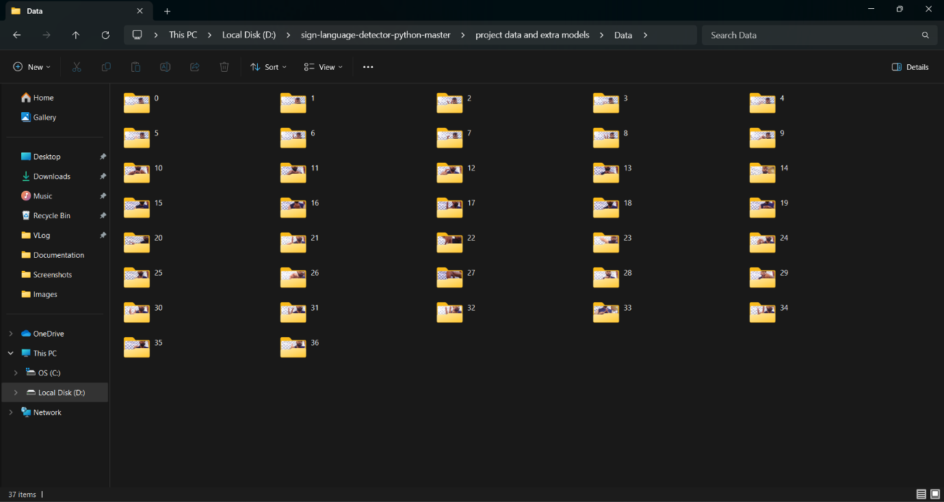Here are the images of created dataset:

Figure14.1 Dataset Collection

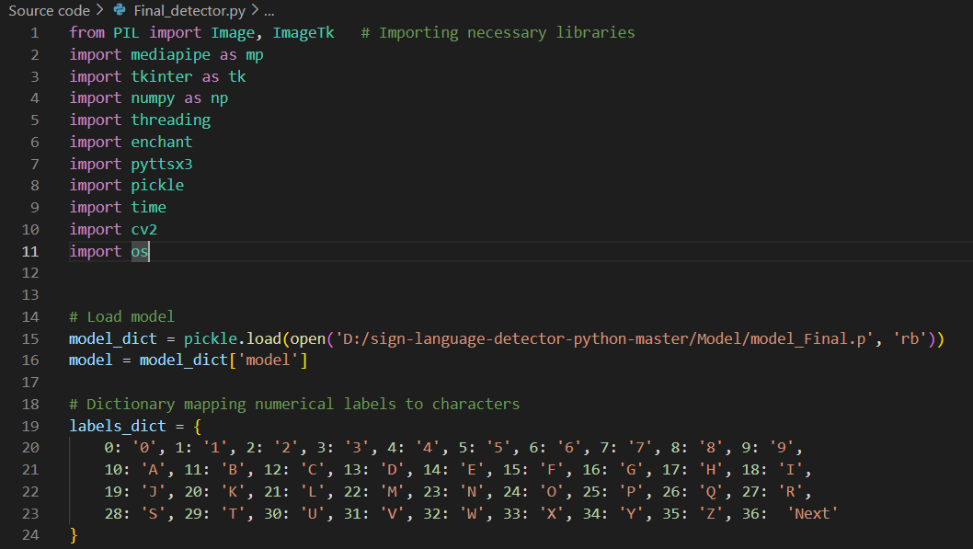

Figure14.2 Mapping of Dataset With Characters

In the image, you can see that we have meticulously curated a dataset comprising 37 characters, encompassing both numbers and alphabets. Each character is represented through a series of accurately captured sign language gestures, ensuring a comprehensive coverage of the sign language alphabet and numerical symbols. This diverse dataset serves as the cornerstone for training our sign language detection system, enabling it to accurately interpret and translate a wide range of gestures into text or speech.

Hand Landmarking On Gestures

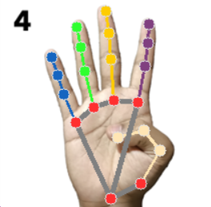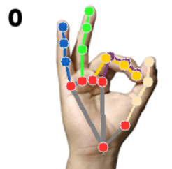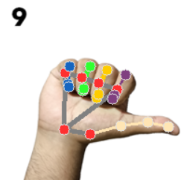

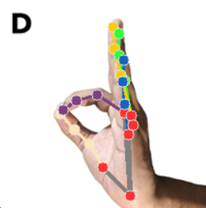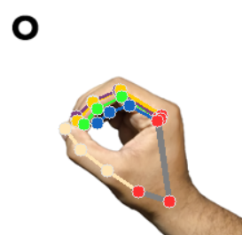

Figure14.3 Hand Landmarking on Gestures

GESTURE DATASET CHART

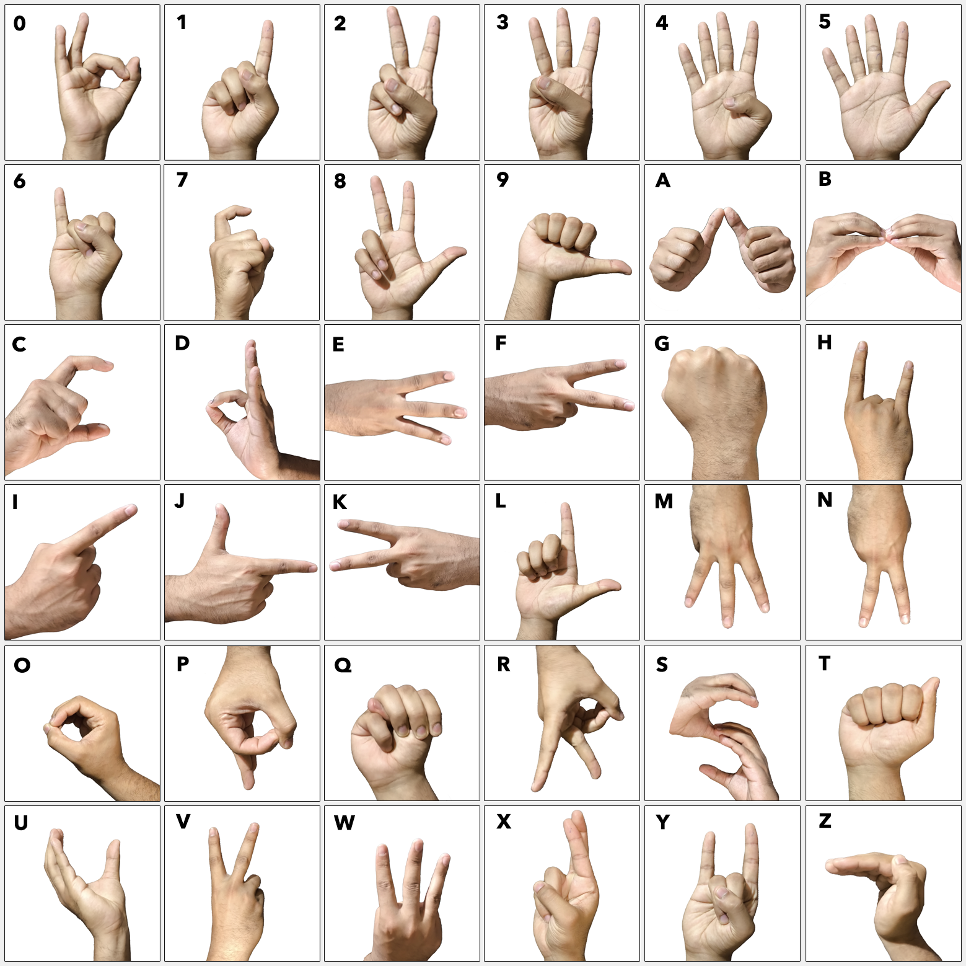

Figure14.4 Gesture Chart

* 1. SITES AND REFERENCES
* REFRENCES
* Adhikary, Subhangi, Anjan Kumar Talukdar, and Kandarpa Kumar Sarma. "A vision-based system for recognition of words used in indian sign language using mediapipe." *2021 Sixth International Conference on Image Information Processing (ICIIP)*. Vol. 6. IEEE, 2021.
* Goyal, Kaushal. "Indian sign language recognition using mediapipe holistic." *arXiv preprint arXiv:2304.10256* (2023).
* Das, Sunanda, et al. "A hybrid approach for Bangla sign language recognition using deep transfer learning model with random forest classifier." *Expert Systems with Applications* 213 (2023): 118914.
* Rao, G. Mallikarjuna, et al. "Sign Language Recognition using LSTM and Media Pipe." *2023 7th International Conference on Intelligent Computing and Control Systems (ICICCS)*. IEEE, 2023.
* Xu, Baoxun, Yunming Ye, and Lei Nie. "An improved random forest classifier for image classification." *2012 IEEE International Conference on Information and Automation*. IEEE, 2012.
* Zaki, M.M., Shaheen, S.I.: Sign language recognition using a combination of new vision-based features. Pattern Recognition Letters 32(4), 572–577 (2011).
* N. Mukai, N. Harada and Y. Chang, "Japanese Fingerspelling Recognition Based on Classification Tree and Machine Learning," *2017 Nicograph International (NicoInt)*, Kyoto, Japan, 2017, pp. 19-24. doi:10.1109/NICOInt.2017.9
* Halder, Arpita, and Akshit Tayade. "Real-time vernacular sign language recognition using mediapipe and machine learning." *Journal homepage: www. ijrpr. com ISSN* 2582 (2021): 7421.
* Matlani, Roshnee, et al. "Real-time Sign Language Recognition using Machine Learning and Neural Network." *2022 International Conference on Electronics and Renewable Systems (ICEARS)*. IEEE, 2022.
* SITES
* <https://www.geeksforgeeks.org/opencv-overview/>
* <https://github.com/google/mediapipe/blob/master/docs/solutions/hands.md>
* <https://www.tutorialspoint.com/scikit_learn/scikit_learn_randomized_decision_trees.htm>
* <https://www.javatpoint.com/python-tkinter>
* <https://chat.openai.com/>
* <https://www.youtube.com/>